

A

Project Study Report

On

**“PP EXTRUDER GEARBOX”**

AND

**“INPUT SHAFT BEARING FAILURE”**

Prepared By

**Saurabh Chaudhari**

From

**National Institute of Technology**

**Rourkela, (Odisha)**

**Under the guidance of Mentor**

**Mr. Rahul Yadav**

**(PP Mechanical)**

# PERIOD: 21 May 2024 to 13 July 2024.



# CERTIFICATE

This is to certify that **Mr. Saurabh Chaudhari** of National Institute of Technology Rourkela has successfully completed a study report on “**PP Extruder Gearboox ”** and a project report on “**Input Shaft Bearing Failure”**, under the guidance of Mr. **Rahul Yadav** (Mentor) at PP Plant, Reliance Industries Limited, Nagothane Manufacturing Division. Dist. Raigad. Maharashtra.

**Mr. Rahul Yadav Mr. Sanjay Athalekar**

**(Mentor PP) (HOD, Mech PP)**

# 

# ACKNOWLEDGEMENT

Firstly, I would like to thank Reliance Industries Limited, Nagothane Manufacturing Division for allowing me to undergo my summer internship at their complex. It was wonderful learning experience to work in such a diverse, well organized plant and under the expert guidance of so many people.

I would like to express my heartfelt gratitude and sincere respect to my mentor **Mr. Rahul Yadav** for his valuable support and expert guidance throughout the project. He was always there to answer my questions, however trivial they might have been.

I am highly grateful to **Mr.Sanjay Athlekar**, HOD of PP Plant for providing me this golden opportunity. I am also highly obliged to **Mr. Sagar Ghode,** Mechanical Engineer of PP Plant for their support and valuable encouragement throughout my project.

Furthermore, I would also like to express my sincere thanks to **Mr.Jaydeep Kotnis (HOD L&D), Mr. Aditya Sahoo** HR for his outstanding management skills related to providing internship and arrangements.

I am indebted to my college, for helping me to perform my training at such an esteemed and highly reputed Industry. Not many people can boast of doing their training at a Fortune 500 Company.

Last but not the least, I would like to express my sincerest gratitude to my parents for their moral teachings and values that they have inculcated in my upbringing to help me become an honest, sincere person and for giving a meaning and proper direction to my life.

**Mr. Saurabh Chaudhari**

**(**NIT Rourkela, Odisha)

# ABBREVIATIONS

**PP** – Poly Propylene

**MFI** – Melt Flow Index

**CES** – Central Engineering Services

**CoE** – Central of Excellence

**CTS** – Central Technical Services

**ENGG.** – Engineering

**HOD** – Head of Department

**LFI** – Learning from Incidents

**RCA** – Root Cause Analysis from Incidents

**SMP** – Standard Maintenance Procedure

**V-01** – Purge drum

**V-02** – Recycle drum

**V-03** – Fresh gas tank

**R-01** – Reactor

**V-12** – MP separator

**V-14** – LP separator

**EX-01** – Extruder

**EX-02** – Master Batch

**A-01** – Stirrer

**V-15** – Extrusion Hopper

**P-11** – Extruder Pump

**D-01** - Dewatering Centrifugal Dryer

**SI-12 –** Start-up product containers

**SI-05** – Control Silos

**SI-11** – Bagging Silos

ABSTRACT

This report presents the findings from a summer internship at Reliance Nagothane, focusing on the extruder gearbox and analyzing input shaft bearing failure. The project covers an overview of the extruder system, detailed examination of the gearbox assembly, and the assembly procedure of the input shaft bearing.

Key aspects include understanding the importance of the extruder, detailed component roles within the gearbox, and a step-by-step assembly guide. The core focus is on the input shaft bearing assembly sequence and identifying reasons for bearing failure, including material defects, assembly errors, operational stresses, and lubrication issues.

The findings aim to enhance maintenance practices and reliability of the extruder gearbox, leading to improved operational efficiency and reduced downtime.

Contents

Certificate 2

Acknowledgement 3

Abbreviations 4

Abstract 5

Brief Process of Poly Propylene (PP) Production 7

PP Plant Overview 9

Project Overview 14

PP Extruder 16

Main Drive and Clutch Coupling 34

Extruder Gearbox 38

Auxilary Drive 40

Gearbox Arrangement 44

Input Shaft Assembly Procedure 49

Detailed Assembly (Workshop) 50

Assembly of Gear Shafts at CES-CWS 61

Site Assembly Work 67

Bearing Failure Analysis and Solutions 71

Project Conclusion 74

**BRIEF PROCESS DESCRIPTION Of**

**POLYPROPYLENE PRODUCTION**

The polypropylene production process is known as 'Spheripol Liquid Monomer Process' and its description is as follow:

**1.1 Catalyst & Co-Catalyst Storage and Metering:-**

The solid catalyst is dispersed into a grease oil mixture and fed to the pre- contacting pot through syringes, which operate hydraulically. The two co- catalysts, one is Aluminium alky (TEAL) and other is Donor, are fed also to the pre- contacting pot where thorough mixing takes places.

**1.2 Bulk Polymerization:-**

The catalyst complex is formed in the pre-contacting pot and pre-polymerized in the presence of propylene in the pre-polymerizer. The pre-polymerized product is then sent to the polymerization reactor where propylene and hydrogen are fed (and ethylene in the case of random co-polymer production). The heat of the reaction is removed by water circulating in the jacket.

**1.3 Polymer Degassing and Propylene Recovery:-**

The polymer slurry is continuously discharged for degassing unreacted propylene in a flash drum, through a steam-jacketed pipe, where the monomer evaporates at about 18 kg/cm²g, is condensed, and recycled to the reaction. The polymer is continuously fed to the second stage degasser. The monomer obtained, after recompression, joins the gas from the flash drum and is fed to the feed drum through the propylene scrubber.

**1.4 Polymer Steaming and Drying:-**

The polymer leaving the second degasser flows to the steamer, where the catalyst is completely deactivated and the monomer still dissolved in the polymer is stripped off. The monomer released is scrubbed to separate the carried polymer and condensate water, then recompressed to Battery Limit for recovery in the Gas Cracker Unit. From the steamer, the polymer is fed to the fluid bed dryer. Absorbed water is removed from the polymer by hot nitrogen circulating in a closed loop. The polymer powder is then conveyed to the silos that feed the extruder.

**1.5 Polymer Powder Storage and Extrusion:-**

From the storage silos, the polymer powder is metered into the continuous mixer, which also receives metered additives prepared in the batch mixer. The additive powder is discharged to the extrusion unit where it is pelletized with an underwater cutter. PP pellets are conveyed to the centrifugal dryer where water is separated, and then to the screen for coarse and fine elimination. The pellets are weighed and sent by pneumatic transport to the analysis and storage silos.

**BASIC OVERVIEW OF POLYPROPYLENE PLANT**

**VARIOUS CHEMICAL SUBSTANCES USED IN PLANT :**

**1.PROPYLENE*:*** Propylene is the most important input to the PP plant. It is fed by the Gas Cracker plant in the form of a liquid at a certain pressure to the feed drum present in the PP plant. A Sundyne pump is used for its circulation. It is also used in the flushing of V-201 (the catalyst preparation tank). Additionally, it is used in the main reactor to maintain a constant solid concentration of the polymer.

**2. ETHYLENE:** Ethylene is used in the production of homo-polymer and random copolymer.

**3. HYDROGEN:** Hydrogen is stored at a pressure of 100 kg/cm²g in two bullets with a total capacity of 130 m³. Through suitable piping connections to the compressor, hydrogen from the bullets will be utilized up to a bullet pressure of 18 kg/cm². Thus, the quantity of hydrogen that is stored and can be utilized when the cracker RSA unit is not operating will be 10,600 Nm³. This quantity will be sufficient to operate both LLDPE trains and the PP plant for 7 days.

During normal operation, the PP plant is supplied with hydrogen at 52 kg/cm² from the bullet(s) through pressure control valve PV-2. Since the requirement is very low, the make-up compressor will be started and stopped manually at periodic intervals to maintain the bullet pressure between 95 and 100 kg/cm²g. Only one of the compressors can be run at a time. When the make-up compressor is running, the booster compressor has to be unloaded.

Hydrogen is moreover used for termination of chain reaction in main reactor. And is used to control the molecular weight of the polymer being formed.

**4. TITANIUM TETRACHLORIDE CATALYST:** TEAL is the co-catalyst used along with the donor and oil-n-grease mixture in the pre-contacting pot V-201 for the activation of the catalyst. It is pyrophoric in nature and the most hazardous chemical out of all.

**5. CYCLOHEXYL METHYL DIMETHOXY SILANE ( CHMMS)/(DONOR):**

This plant has been designed to operate with different donor types, i.e., PES (phenylethoxysilane) or DPMS (diphenylmethoxysilane), known as C Donor and D Donor, respectively, according to the type of polymer being produced. The consumptions also vary in accordance with the production. The donor, along with TEAL, helps in the activation of the catalyst in the pre-contacting pot.

Apart from the above mentioned chemicals gases like CO and CO2 are used for termination of reaction in cases of shutdown or emergency(3% CO is used in the 6 legs of main reactor and 30% is used in the filters F-201).

Other utilities of the PP PLANT are:

1. Instrument Air
2. Plant Air
3. Cooling Water
4. Steam
5. Nitrogen
6. DM Water
7. ATMER: To deactivate TEAL. It possess antistatic property and non-sticky property.
8. Caustic(NaOH): It is used in the oil regeneration tank to neutralize TEAL. It is also used in pellet-cutting water for its anti-sticking properties, thereby preventing lump formation.
9. Additives: They are added in the extruder along with PP powder to enhance the processibility and features in final PP products

The plant consists of a production line for polymer pellets with a capacity of 60,000 t/y, producing colorless polypropylene pellets using the Spheripol process. This includes both 'homo polymer' and 'random copolymer' types. The plant is equipped with facilities relevant to the process, such as high-pressure and low-pressure blow-down systems, chilled water refrigeration units, condensate recovery, nitrogen booster compression, an exhaust oil recovery unit, and a hydrogen storage facility.

The process units at the site of PP plant are numbered from 100 to 900. Following is the description of the processes being carried out in each area:

1. **Area 100 – Catalyst and Co catalysts Storage and Metering:-** The solid catalyst is dispersed into a grease-oil mixture. The three catalyst components (supported titanium, aluminum alkyl, and donor) are fed to the pre-contacting pot V-201 in the required ratio.
2. **Area 200 – Bulk Polymerization:-** The catalyst complex is formed in the pre-contacting pot V-201 and prepolymerized in R-201.

The prepolymerized product is sent to the polymerization reactor R-202, which is also fed with propylene (to maintain a constant solid concentration), hydrogen (to control the molecular weight of the polymer), and ethylene (in the case of random copolymer production).

The heat of the reaction is removed by water circulating in the jacket. The total catalyst residence time in the reactor is about 2 hours.

1. **Area 300 – Polymer Degassing and Propylene Recovery:-** The polymer slurry is continuously discharged to the first stage degassing unit V-301 through a steam-jacketed pipe, where the monomer evaporates. The gas leaving the flash drum, which operates at about 18 kg/cm²g, is condensed and recycled to the reaction via column C-301.

The polymer is continuously fed to the second stage degasser F-301, which operates near atmospheric pressure. The monomer obtained, after recompression, joins the gas from V-301.

1. **Area 500 – Polymer Steaming and Drying:-** The polymer leaving the low-pressure degasser F-301 flows to the steam fluid bed FB-501, where the catalyst is completely deactivated and the monomer still absorbed in the polymer is stripped out. The monomer released is scrubbed to separate the carried polymer and condensed water, and then recompressed to B.L. for recovery. From the steaming bed, the polymer flows by gravity to the fluid bed dryer FB-502.

The water absorbed by the polymer during steaming is removed with hot nitrogen in a closed loop. From the dryer, the polymer powder is pneumatically conveyed to the two storage silos that feed the extrusion and pelletizing line.

1. **Area 600 – Polymer Powder Storage and Extrusion:-** From the storage silos SI 601A/B, the polymer powder is metered into the continuous mixer WM-602, which also receives the additives master batch prepared in the batch mixer WM-601 in the required ratio. The additive powder is then discharged to the extrusion unit PK-603, where it is pelletized with an underwater cutter. PP pellets are conveyed to the centrifugal dryer PK-604, where water is separated, and then to the screen WS-601 for coarse elimination.

The pellets are weighed on a continuous belt weigher, if operational, and sent by pneumatic transport to the storage silos. These pellets undergo hourly analysis during production to ensure quality.

1. **Area 700 – Pellets Analysis, Homogenization, Storage and bagging:-** PP pellets coming from the extrusion line are analyzed hourly and stored in the four silos SI 701 A to D. A pneumatic transport system feeds the analyzed product to the homogenizer silo SI 702, and from there to the bagging silos SI-703 and SI-704 (which can also be fed directly from the extruder). These silos feed the bagging units PK 701A/B by gravity.
2. **Area 800 – Process Facilities:-**

This Section Includes:

* High pressure and low pressure blow-down.
* Chilled water refrigeration unit.
* Condensate recovery.
* Nitrogen booster compression

1. **Area 900 – Liquid Effluent Treatment:-**

This Section Includes:

* Exhaust oil recovery unit, where the oil contaminated by TEAL is batch wise regenerated by neutralization with caustic and sent to stores for further disposal.
* Waste water primary treatment.

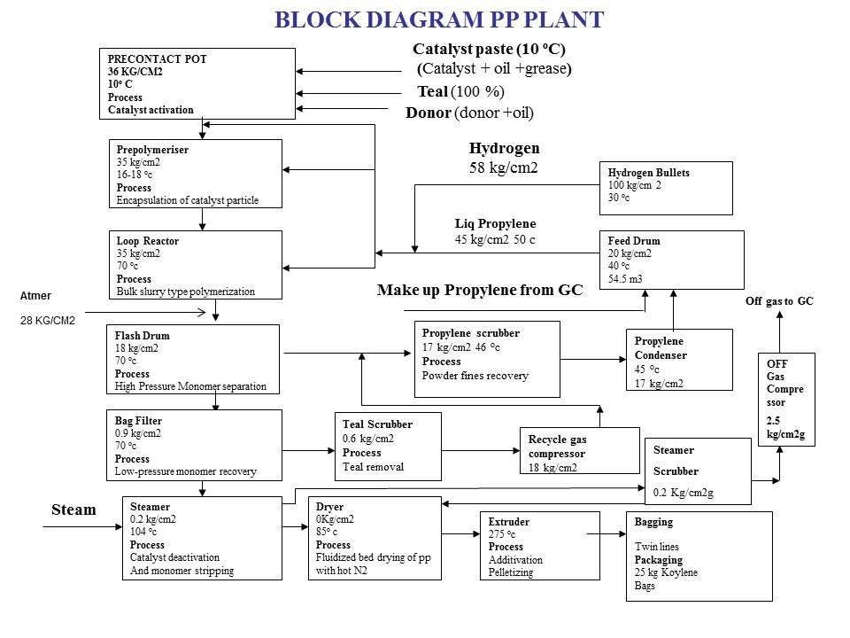

**PROJECT OVERVIEW**

**Objectives**:

* Overview of the extruder
* Extruder gearbox overview
* Detailed assembly procedure
* Input shaft bearing assembly sequence
* Identification of reasons for bearing failure

**Project Overview:**

This report documents the findings and activities undertaken during my summer internship at Reliance Nagothane, where the primary focus was on studying the extruder gearbox and analyzing input shaft bearing failure. The project was divided into several key areas, each essential for understanding and addressing the bearing failure issues.

1. **Overview of the Extruder:**

The project begins with a comprehensive overview of the extruder, detailing its function, significance in the manufacturing process, and the various components that contribute to its operation. Understanding the extruder's role is crucial as it sets the context for the gearbox's importance.

1. **Extruder Gearbox Assembly:**

The next section provides an in-depth examination of the extruder gearbox. This includes a breakdown of the gearbox components, their functions, and how they interact within the system. Detailed diagrams and descriptions are used to enhance understanding of the assembly.

1. **Detailed Assembly Procedure:**

A step-by-step guide to the assembly procedure of the extruder gearbox is provided. This includes the tools and techniques required, safety considerations, and best practices to ensure a precise and efficient assembly process.

1. **Input Shaft Bearing Assembly Sequence:**

Focusing on the input shaft bearing, this section outlines the specific sequence of assembly steps. Each step is explained in detail to highlight critical points that could influence the bearing's performance and longevity.

1. **Identification of Reasons for Bearing Failure:**

The core of the project is the analysis of input shaft bearing failures. Various potential causes are explored, including material defects, assembly errors, operational stresses, and lubrication issues. This analysis is supported by both theoretical insights and practical observations gathered during the internship.

The findings and insights gained from this project aim to contribute to improved maintenance practices and enhanced reliability of the extruder gearbox at Reliance Nagothane, ultimately leading to better operational efficiency and reduced downtime.

**PP EXTRUDER**

**Basics of Extruder :-**

**Extrusion** is the act or process of shaping by forcing through a die.

**Goal of Extrusion** : To provide the molten polymer to the forming process at the desired rate, uniformity and quality to produce the finished product with specification.

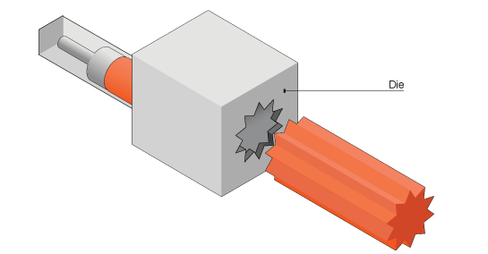A machine that is used to extrude a material is called an **Extruder**. Many different materials can be extruded, for instance clays, ceramics, food, metals, and of course plastics.

**Functions of Extruder:** To generate sufficient pressure to force the material through a die. It depends on geometry of the die, flow properties of material, flow rate

So, basically, an extruder is a machine capable of developing pressure.

**Extrusion process**

**Types of Extruder in Plastic Industry:**

1. The Screw Extruder
2. The Ram Extruder
3. The Drum or Disc Extruder

A screw extruder operates with a screw rotating within a cylinder. The rotation of the screw creates a pumping action, which is essential for the extrusion process.

Screw extruders can be classified into two main categories:

1. **Single-Screw Extruder:-**
   * The single-screw extruder is the most common machine in the plastics processing industry. It features a single screw rotating within the cylinder, which is responsible for the material's movement and pressure buildup.
2. **Multi-Screw Extruder:**
   * Multi-screw extruders, specifically twin-screw extruders, are widely used in various applications. Twin-screw extruders have two screws, which can be configured in different ways:
     + **Co-Rotating Twin-Screw:** Both screws rotate in the same direction.
     + **Counter-Rotating Twin-Screw:** The screws rotate in opposite directions.
     + Twin-screw extruders can operate at high or low speeds depending on the application.
       - **High-Speed Extruders:** Running at around 200 to 500 rpm or higher, these are primarily used in compounding applications.
       - **Low-Speed Extruders:** Operating at about 10 to 40 rpm, these are mostly used in profile extrusion applications.
       - Another distinguishing feature of twin-screw extruders is the extent of intermeshing of the screws:
         * **Intermeshing Twin-Screw Extruders:** Most twin-screw extruders are intermeshing, where the screws interact closely, enhancing the mixing and processing capabilities.
         * **Non-Intermeshing Twin-Screw Extruders:** These have screws that do not interact as closely, allowing for very long lengths without the concern of metal-to-metal contact. They can achieve L/D ratios as high as 100:1 or more but have poorer dispersive mixing capability.

**TYPICAL EXTRUDER COMPONENTS**

***Componnts of Extruder:***

1. 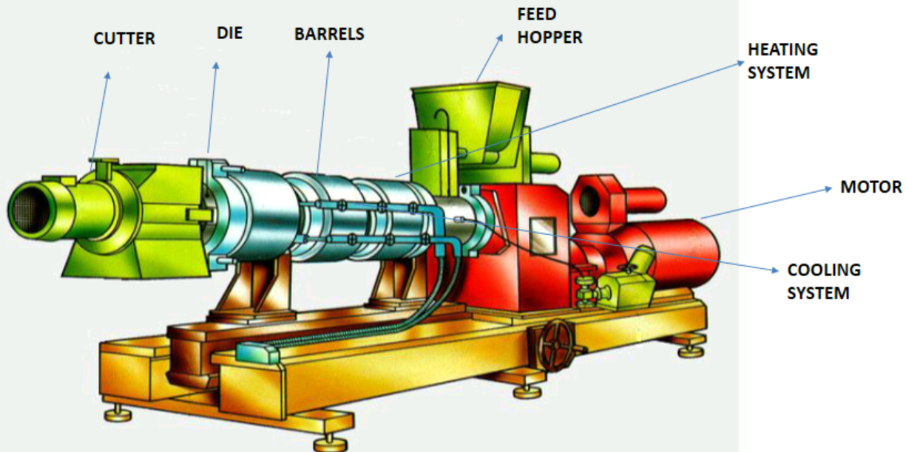Motor and Gearbox
2. Heatiing System
3. Cooling System
4. Feed Hopper
5. Barrels
6. Die and die holder
7. Cutter
8. Diverter valve
9. Underwater pelletizer
10. Gala Dryer

**Extruder**

**EQUPMENT TAG:** 40PK603

**MODEL:** ZSK 240

**MAKE:** COPERION (WERNER & PFEIDERER)

**TYPE:** TWIN SCREW CO-ROTATING CLOSELY INTERMESHING COMPOUNDER.

**MOTOR RATING:** 3.4 MW, 11 KV

**GEAR BOX:** BD 108/205 R70

**MAKE:** RENK GMBH

**RPM:** STEP 1- 252 rpm

STEP 2- 228 rpm

**AUXILIARY MOTOR RATING:** 45 kW, 415V

|  |  |
| --- | --- |
| Parameter | Value Range |
| Melt Flow Index | 1.5 to 40 g/10 minutes |
| Product | Pellets |
| Pellets Shape | Cylindrical |
| Pellets Size | Mesh 4 to Mesh 8 size |
| Average Weight | 25 – 28.5 mg/pellet |
| Capacity | 15000 kg/h (nominal) |

**DETAILS OF PP EXTRUDER**

The Screw Extruders are basically Volumetric Pumps. They are not the positive displacement devices. Variations in feeding will result in variations in output

**Process Steps of an extruder are following :**

* Solids Conveying
* Melting
* Pumping
* Mixing

Output rate of an extruder has a direct correlation to solids conveying.

**SCHEMATIC OF EXTRUDER:**



**I.Motor and GearBox:**

The primary function of the extruder driving unit is to supply power for rotating the extruder screws, with part of this energy converted into heat due to friction within the barrel. Typically, the driving unit comprises an electric motor and gearbox. The motor's power rating is determined by the extruder size and throughput requirements, ranging from 10 kWhr to 120 kWhr per ton depending on the degree of shearing.

In single-screw extruders, the gearbox features a single output shaft, simplifying its construction. Twin-screw extruder gearboxes, however, have two output shafts rotating at equal speeds to drive both screws. Due to space constraints, the gearbox bearings must accommodate radial and thrust loads from the screws, often requiring a combination of bearing types for optimal performance.

**II.Resin Hopper:**

The resin hopper is the initial storage and entry point for solid plastic resin before it is fed into the extruder. Constructed from durable, corrosion-resistant materials, the hopper typically features a conical shape to facilitate resin flow. It varies in capacity based on the extruder size and production requirements. Key features include feed mechanisms like screw or vibratory feeders, level sensors for optimal feed rates, anti-bridging devices to prevent resin clumping, and dust extraction systems for a cleaner environment.

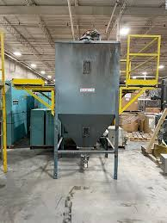

Loading and replenishment of the resin hopper can be manual for small-scale operations or automated using pneumatic conveyors or vacuum loaders in larger setups. Some hoppers include heating elements to preheat the resin and drying systems to remove moisture from hygroscopic resins, ensuring consistent processing temperatures and preventing defects in the final product. Maintenance is simplified with access points and inspection windows for easy cleaning and visual checks.

The resin hopper is essential for various applications, from general plastic products to specialty compounds. Its design ensures consistent and controlled resin feed, enhancing product quality and process efficiency. Automated systems reduce manual intervention, while quality control features like anti-bridging devices and drying systems maintain the resin's integri ty, leading to high-quality extruded products.

**III.Barrel Hopper:**

The barrel of an extruder is a crucial component designed with precise machining to accommodate the screw with minimal clearance tolerance. It serves several essential functions in the extrusion process, including:

1. **Barrel Heating Zones:**

* The barrel is divided into multiple heating zones to maintain a consistent temperature profile. These zones can be heated either electrically or with oil.
* Electrically heated zones require cooling, which is achieved by circulating barrel cooling water through jackets surrounding the barrel.

1. **Types of Barrels:** 
   * **Powder Entry Barrels:** These barrels facilitate the initial entry of polymer powder into the extruder.
   * **Degassing Barrels:** Designed to remove volatile components and gases from the polymer melt.
   * **Fully Enclosed Barrels:** These provide controlled environments for specific processing stages.
2. **Barrel Configuration:**
   * Each barrel is typically configured in an '8' shape to enhance mixing and residence time of the polymer within the extruder.
   * The '8' shape design promotes thorough mixing and ensures efficient melting and homogenization of the polymer.
3. **Temperature Regulation:**
   * Precise temperature control is essential for effective polymer melting and homogenization.
   * Heater plates and temperature controllers are strategically placed along the barrel to maintain optimal temperatures at different stages of the extrusion process.
4. **Barrel Cooling Water Circuit:**
   * To counteract heat generated during pressurization and maintain stable temperatures, each barrel is equipped with a cooling water circuit.
   * Cooling water circulates through the barrel jackets, absorbing excess heat generated during polymer processing.
5. **Reducing Operational Noise:** 
   * Water exiting the barrels can create knocking in the header due to pressure differentials.
   * Spargers installed in each outlet line help minimize hammering and noise, ensuring smooth operation and consistent extrusion performance.

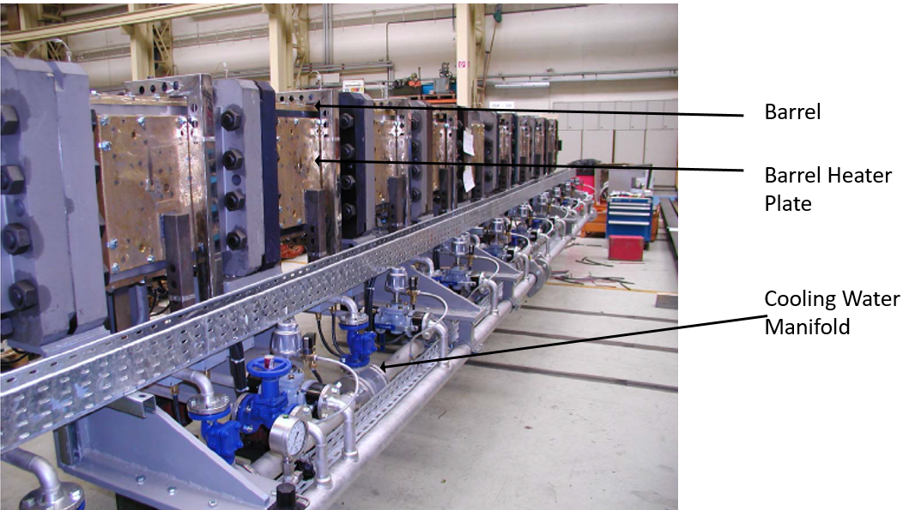

The barrel of a twin-screw compounder plays a critical role in the extrusion process by providing controlled heating, facilitating efficient polymer melting and homogenization, and maintaining precise temperature profiles through sophisticated cooling mechanisms. These features collectively ensure high-quality output and operational reliability of the extrusion system.

**IV. Screw:**

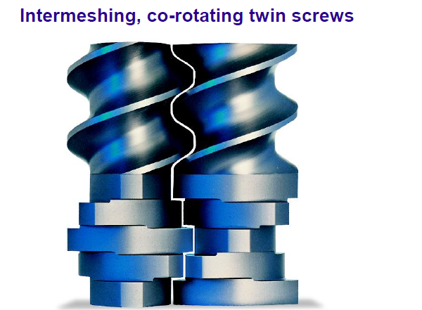The Extruder Processing Section is the ‘heart’ of an extruder that helps to achieve the desired quality of compounded material, output level and performance.

Several actions are carried out on the material as it works its way through the extruder and exits from the die

Proper configuration with the right choice of elements and barrels, optimizes the performance of each zone.

The entire length of the processing section is mainly divided in to following zones:

* **Zone 1: Intake/ Feeding Zone:** This zone is primarily the polymer powder receiving zone from the feeding mechanism.
* **Zone 2: Kneading/ Melting Zone:** In this zone, the polymer undergoes phase transformation associated with reaching the required melt viscosity or melt temperature. Frictional heat generated due to shearing action, increases the temperature of the polymer to the required process temperature. This melt mixing is achieved by Kneading Elements by the amount of shearing between the tip of the kneading block and the barrel. The intensity of shear experienced by the material will vary depending on the gap it passes through as the Kneading blocks complete a full rotation.
* **Zone 3: Conveying Zone:** Conveying Efficiency is the ability of the element to move the material forward in the extruder. It is 100%, if all the material moves forward at the completion of each turn of rotation.
* **Zone 4: Mixing Zone**: Mixing is an essential function in an Extruder. The Goal of the mixing process in an extruder is to increase the uniformity of the composition. Frictional heat generated due to shearing action, increases the temperature of the polymer to the required process temperature. This melt mixing is achieved by Kneading Elements by the amount of shearing between the tip of the kneading block and the barrel.
* **Zone 5: Venting Zone:** Venting is required to continuously remove air and moisture (or volatiles) during or after the melting stage.
* **Zone 6: Metering Zone:** Metering forms the final processing zone in an Extruder. The function of this zone is to build the required pressure for filtration of foreign particles (if called for) and at the die for a continuous streamlined output. This zone is also called the pumping zone in an extruder. The compounded polymer melt is transported towards the die by drag flow caused by the rotating action of the screws.

**Screw Elements:**

* There are total 52 elements installed on 2 shafts of extruder PK603
* There are two types of elements as according to conveying direction- right handed and left handed
* 50 elements are right handed for conveying the polymer towards the die plate and 2 elements are left handed mounted just after the degassing section to restrict the flow and facilitate better degassing
* All the elements are Nitrided to make them wear resistant
* 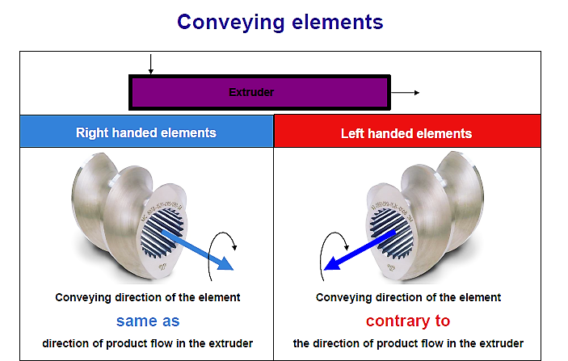Different profiles are given to screw elements as per process sections like kneading, mixing and conveying elements
* Two or three start elements are used commonly
* In ZSK 240 two start elements are used

**Screw Element Mounting:**

* 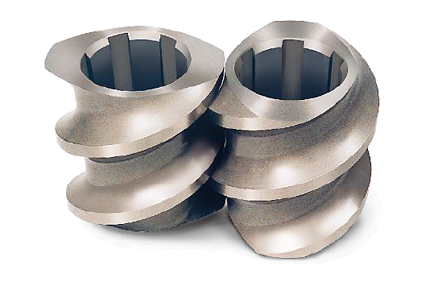Different mounting types are available in the screw elements as per shaft design in different extruder models
* Multiple key or spline designs are available for different extruders
* Screw elements for ZSK 240 in PP Plant have 6 key design as shown
* Elements have a fixed sequence in which they should be mounted and not doing so will result in profile mismatch
* After the elements are mounted, they are held in position by means of a hydraulic nut and tensioning is done at 700 bar
* A left handed end cap is provided at the end of the shaft to protect the hydraulic nut from unfastening by polymer clogging

**V. Die Zone and Cutter:**

**Die Zone**: The die zone transforms the molten resin into a sheet or a profile by passing the melt through a precision die. The die plate functions as a restriction and forming device mounted at the end of the barrel. By adjusting the die opening, the pressure, retention time, and the dimensions and shape of the final product can be controlled. For small-scale extruders, the die assembly has only one opening. Multiple openings are available for large- or commercial scale extruders.

**Cutter:** A cutter consists of a group of rotating knives mounted in front of the die plate. Cutters are used to cut the extrudate into finite lengths. The rotational speed of the knives is adjustable. The length of extrudate is determined by the number of knives and the rotational speed of the knives.

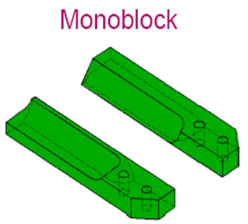Cutter blades for the PK603 are available in various constructions, including monoblock and bi-metal configurations. Monoblock blades are made entirely of the same material, typically Nikro 128 or Nikro 143. Bi-metal blades, on the other hand, feature Nikro inserts mounted on tool steel, which helps to reduce costs. For the PK603, we use composite material blades made of either Nikro 128 or Nikro 143. The composition of the blades significantly influences their service life, with Nikro 128 providing approximately three months of use due to its softer nature, while the harder Nikro 143 extends the service life to around six months.

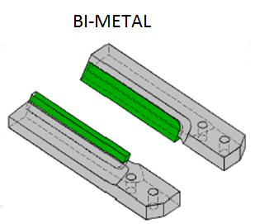The hardness of the blades also affects the lifespan of the die plate. Although Nikro 143 blades offer a longer service life, they tend to shorten the life of the die plate due to their increased hardness. This trade-off must be considered when selecting blades to balance both the cutter and die plate lifespans. Regular monitoring of blade condition is essential to ensure optimal performance and to avoid unnecessary wear on the die plate.

Blade replacement is primarily determined by blade thickness and the condition of the edges. New blades start at a thickness of 12 mm and should be replaced when they wear down to 10.5 mm. Additionally, it is recommended to replace the entire set of blades at once as a part of good maintenance practice. This ensures uniform performance and prevents uneven wear, thereby maintaining cutting efficiency and prolonging the lifespan of both the cutter blades and the die plate.

**VI.** **Melt Pump:**

Some extruder are installed with Melt Pump for the metering purpose. A melt pump may be used between the head of the barrel and the die to accomplish several things. The use of melt pump also enables the barrel to run at a lower pressure. This minimizes wear and tear on the screw/barrel assembly. A melt pump is an intermeshed set of gears, run by the melt pump motor and drive assembly.

**VII. Visco Seal:**

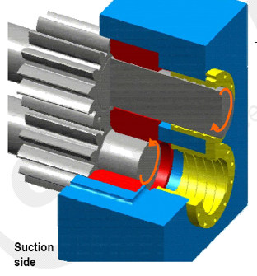In the realm of extrusion processes, the Visco-Seal plays a pivotal role in containing the powder-additive mixture within the extruder's DE (Discharge End) side. This mechanical seal is ingeniously designed to create a tortuous path, effectively thwarting any potential leakage. Fundamentally, the Visco-Seal operates under oil heating, crucial for melting the powder within the mixture, thereby forming a barrier against further leakage. At the seal's terminus, where the molten polymer reaches, it solidifies, acting as an additional safeguard to prevent the escape of molten polymer. This innovative design incorporates a helical groove that not only aids in maintaining seal integrity but also ensures that any rotating shaft movement actively redistributes molten polymer inward, reinforcing containment efficiency..

In practical terms, the Visco-Seal exemplifies advanced engineering solutions tailored to extrusion challenges, particularly in ensuring the secure containment of materials throughout the extrusion process. Its dual functionality of heat-induced melting and strategic groove design underscores its critical role in mitigating potential leakages, thereby enhancing operational reliability and product quality in extrusion operations. This pivotal component not only supports the seamless flow of production processes but also underscores the importance of precision engineering in optimizing industrial operations for enhanced efficiency and performance reliability.

**VIII. Screen Pack Changer:**

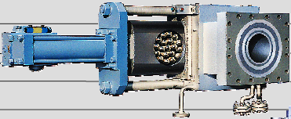The Screen Pack Changer (SPC) unit serves a critical role in maintaining the quality of extruded products by preventing foreign particles from reaching the die plate. Comprising a holding plate with twelve cylindrical filter elements, each element features a supporting basket and a wire cloth filter insert. Filter replacement is determined by melt pressure; elevated pressure signals contamination, prompting a changeover without interrupting extrusion operations. Crucially, this process occurs while the extruder continues to run, ensuring continuous production.

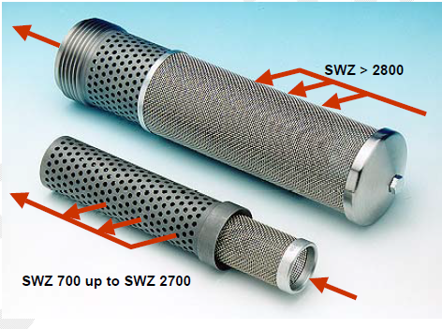To facilitate filter replacement, a dedicated hydraulic unit with an oil pump and two accumulators maintains a constant pressure of 160 bar. However, immediate changeover to a freshly installed screen pack is cautioned against due to significant temperature differentials. Therefore, new screen packs must be installed at least two hours prior to changeover to allow for temperature stabilization. Additionally, a cooling jacket surrounds the screen pack to prevent polymer leakage through the body and slider, with the cooling water isolated during SPC changeovers.

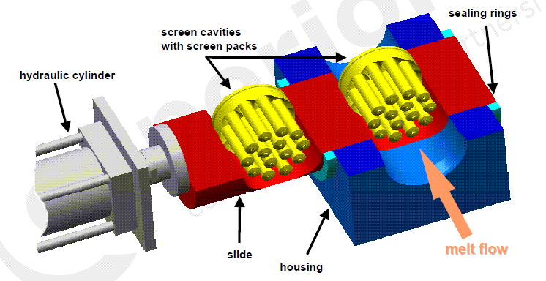Each cartridge houses twelve filters, and an additional standby cartridge ensures continuous operation. The filter mesh sizes vary, including 800, 1000, and 1200 microns, tailored to accommodate different grades within the PP Plant. Melt flow through the screen pack follows an outside-to-inside path across the elements, optimizing filtration efficiency and product quality.

This setup not only ensures operational continuity and product quality but also underscores the importance of proactive maintenance and careful temperature management in extrusion processes.

**IX. Pelletizing System:**

The pelletizing system consists of two main components :

* Die Plate and
* Pelletizer

The primary function of the pelletizer is to ensure uniform polymer flow and precise pelletization according to specified size and rate requirements. To achieve this, the die plate is equipped with a uniform heating system to maintain wall temperatures above the polymer's recrystallization point, ensuring consistent product quality and prolonging the die plate's service life. Additionally, the pelletizer is designed for safe and straightforward operation, facilitating the transportation of pellets without agglomerate formation, thereby maintaining product integrity throughout the manufacturing process.

**Die Plate:**

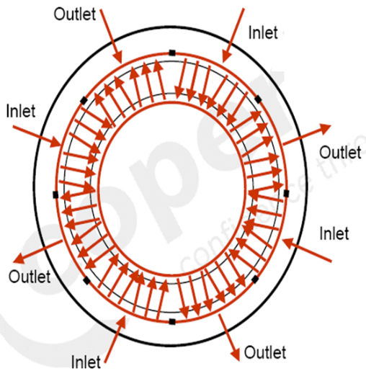The extruder features an intensively heated die plate specifically designed for Polypropylene applications, employing a single-row configuration with Tungsten Carbide blocks strategically placed for enhanced wear resistance within the die plate body. This design incorporates a single row of die holes per slot, optimizing heat transfer efficiency compared to traditional layouts. Uniform oil heating is facilitated through inlet and outlet ports, crucial for maintaining a consistent temperature range of 260-275°C using thermic fluid (Marlotherm-S). Separate hot oil units are allocated, one dedicated to the die plate and Visco seal, and another for the diverter valve and SPC unit, ensuring precise thermal control throughout operations.

The die plate integrates 754 2.6 mm Ø holes through which polymer extrusion occurs, critical for maintaining product quality. Periodic replacement of the die plate is recommended upon observing throughput loss, die freezing, or significant variability in pellet size. Refurbishment of the die plate involves a process of oven heating and surface grinding, extending its operational lifespan and maintaining extrusion performance over time.

**Pellitizer:**

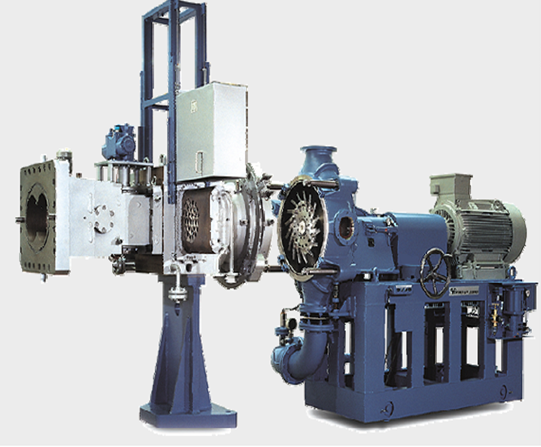 In the pelletizer assembly, key components like the rotor and die plate are crucial for cutting pellets, mounted on a trolley for easy detachment. A water chamber with inlet and outlet hoses facilitates pellet conveying using demineralized (DM) water, crucially maintained at a pH of 9 to 9.5. Maintaining this alkaline pH is essential as acidic conditions can accelerate blade edge corrosion and lead to pellet agglomeration, impacting cutting efficiency.

The rotor, featuring 12 equi-spaced cutters (with provisions for 18), is flexibly mounted on rubber bushings to enhance operational flexibility. It's secured to the pelletizer shaft via a key and locking center bolt. During operation, the shaft movement, controlled by hydraulic cylinders, ensures a gap of 1.5 mm to 2 mm between the cutter blades and die plate, crucial for efficient pellet cutting and preventing polymer lump formation at startup.

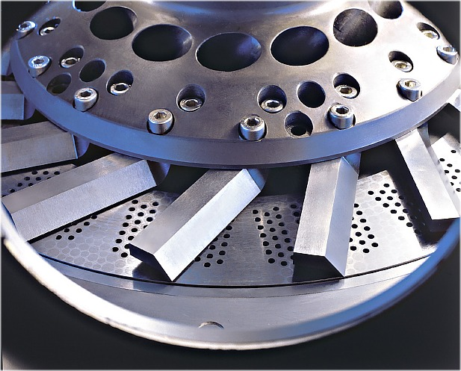Upgraded versions of the pelletizer automate docking with an electro-hydraulic mechanism, improving operational efficiency. After installing a new die plate or blades, grinding is recommended to ensure even blade patterns. Lubricating the pelletizer blades with silicon grease before grinding or startup prevents polymer adherence, optimizing cutting performance.

Routine maintenance includes ensuring die holder and die plate are filled with melt to prevent water ingress, which can cause thermal shock and damage equipment. Proper alignment of the pelletizer motor and shaft, with acceptable offsets of 0.03 - 0.05 mm, is essential after major maintenance to maintain operational precision. The pelletizer, mounted on six rubber bushes, mitigates vibrations and accommodates thermal shocks during operation, supporting its robust performance driven by a 75 kW variable-speed motor.

This overview highlights the critical operational mechanisms and maintenance procedures of the pelletizer assembly, emphasizing its role in efficient pellet production and equipment longevity in extrusion processes.

**X. Gala Dryer:**

* 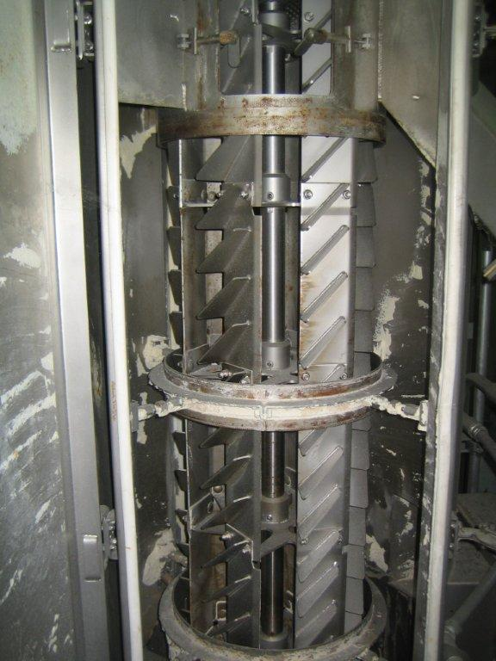A centrifugal dryer manufactured by Gala Industries Inc. is installed for separation of pellets and water.
* Model number is 32.4 DW (Low Noise Dryer)
* It is driven by a motor at 414-429 RPM by means of a 05 no V-belts
* The rotor also is shown alongside which lift the pellets and is supported by two flanged bearings at the bottom and the top of the dryer
* It uses a screen to separate the pellets from water.

**Dryer Working Principle:**

After the polymer is pelletized by rotating blades, the pellets are transferred by water to a dryer where they are separated and discharged. This pellet water operates in a closed cycle, necessitating cooling, straining, and maintaining a pH of 9 to prevent agglomerate formation. In the provided diagram, the red, blue, and green colors represent the flow of pellets, water, and air respectively.

Pellets exiting the pelletizer cutting chamber are transported via process water through pipes to an agglomerate catcher located at the centrifugal dryer’s inlet. The agglomerate catcher, which features a slide gate with inclined bars and a pneumatically operated slide gate, safeguards the dryer by filtering out larger pellet clusters (agglomerates) larger than 25mm that may form during start-up. This prevents the dryer rotor from potential damage caused by these large clusters.

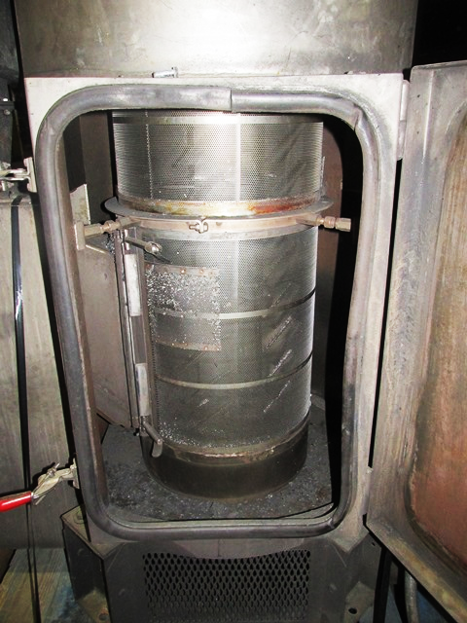Once inside the rotor section of the dryer, the pellets and residual water flow are propelled by centrifugal force. The rotor's speed and the design of the lifters within it cause the pellets to bounce between lifters and screens, moving in a helical path. During this process, the water is separated through the screens, and the pellets continue to the upper section of the dryer where they are ultimately discharged. This drying process efficiently reduces the residual surface moisture of the PP pellets to approximately 0.06%.

In the final drying phase, occurring in the upper two-thirds of the screen surface and in the pellet outlet chute of the dryer, dry countercurrent air flow generated by an external exhaust fan (B605) further decreases the surface moisture. This air flow, coupled with the internal temperature of the pellets, creates a slight vacuum that prevents humid air from entering the room or condensing in downstream equipment components, ensuring optimal drying conditions.

**Common Issues and General Precautions:**

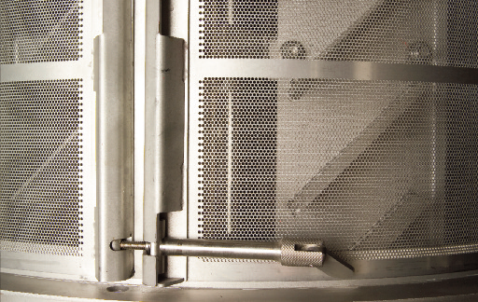The screens within the centrifugal dryer play a crucial role in retaining the pellets in the rotor area as they move upward toward the outlet. These screens are secured using a special thimble design, as illustrated in the accompanying diagram. Ensuring that the screen is precisely placed on the designated step is essential to prevent pellets from escaping through clearances and entering the pellet cutting water filters (F607A/S). The presence of pellets in these filters could also indicate that the screens are damaged, necessitating immediate attention and repair.

Proper installation of the screens is paramount to the efficient functioning of the centrifugal dryer. Any misalignment can lead to operational inefficiencies and contamination of the water filtration system. Additionally, care must be taken when installing the windows, which have special gaskets designed to seal against water. The joint on the gasket should always be positioned on the upper side to prevent water leakage. This attention to detail ensures the integrity of the seal and the overall efficiency of the drying process.

Over-tightening the enclosure during installation should be avoided, as it can damage the gasket, leading to potential water leakage and subsequent operational issues. By following these meticulous installation and maintenance procedures, the centrifugal dryer can operate at optimal efficiency, ensuring high-quality pellet production and minimizing downtime due to equipment malfunctions or maintenance requirements.

**MAIN DRIVE**

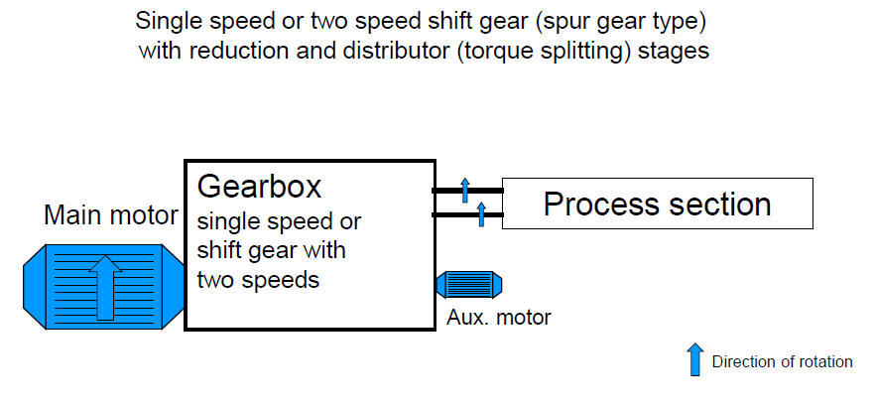

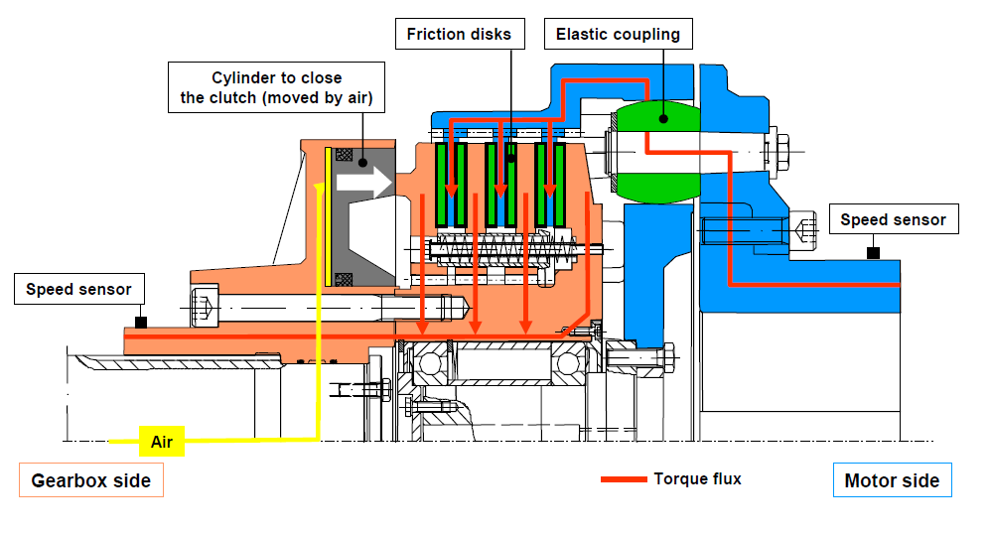



**Clutch Coupling:**

MAKE : M/S Desch Antriebstechnik GmbH

MODEL : PLANOX PPF243

* A clutch is a mechanical device which provides for the transmission of power from the driving member i.e. motor to another driven member i.e. Gearbox
* The clutch connects the two shafts so that they may be locked together and spin at the same speed (when engaged), locked together but spinning at different speeds (slipping), or unlocked and spinning at different speeds (when disengaged).
* Thus, the clutch transmits torque from the motor to the transmission and a release mechanism allows the driver to control the flow of torque between them.
* Clutch mechanism also prevents overloading of the machine.
* Air is fed in through the bore of input shaft by means of a rotary union joint.
* 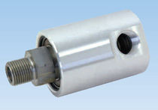Many interlocks have been given in Extruder system where Clutch gets disengaged immediately after actuation of interlock on different mode of failures like –High torque, Low torque, Pelletizer low speed, High melt pressure etc.
* Rotary union joint is a specially designed joint which is directly connected to extruder input shaft by threaded joint. This Threaded joint is rotated with shaft. The outer shell has air connection port and Instrument air is supplied through it for friction coupling. Rotary union consists shield ball bearing and Mechanical seal inside the shell for providing rotary movement to inner hollow shaft and air tight joint.

**Rotary Union**

* Any leakage from this Rotary union will lead to low pressure for Clutch coupling and it will slip and gets decoupled.
* The air forces the friction discs against the linings. This causes frictional connection leading to mechanical engagement.
* The power is transmitted from motor hub through the friction linings and friction discs to the gear shaft
* When the air pressure is vented, the friction linings and discs are separated and the power transmission is completely interrupted.
* The clutch is so designed, that the complete friction pack can be removed and replaced without moving the motor or removing the gear drive shaft coupling hub.
* Friction disc length must be monitored/measured periodically to estimate the life.
* Speed sensors are provided at DE and NDE side hubs to indicate the speed as well as disengage the clutch when there is a speed difference 2 rpm between the two hubs.
* Clutch engage pressure is 3 kg/cm2 as per data sheet. It should not be increased without following OEM procedure and consultation with OEM
* Functioning of friction coupling may be affected due to ingress of oil.

The clutch between the main drive and gearbox has an important safety function.

**To Protect the plant against consequential damage, it will disengage when:**

* Clutch is overloaded i.e. 120% of the nominal machine torque
* Air pressure is high
* Thrust pressure by the product is too high
* Failure/ fault of the underwater pelletizer
* Clutch slip is more than 4 revolutions/ 2 minutes
* Emergency off button is actuated.



**Extruder Gearbox**

**Functions of Extruder Gear box:**

* Reduction of motor speed to the requested speed
* Increase of motor torque to required torque of screws
* Drive of the screws in co-rotating mode
* Transfer and distribution of motor power to both screws
* Timing of both the screw shafts
* Balancing of the thrust forces out of the extrusion process

**General Description:**

* The gear unit is a two stage reduction helical shift gear unit with multiplicity of power transmission paths for the drive of the double screw extruder.
* The input drive shaft and the output drive shafts are located in parallel along a pitch plane, the input drive shaft being hollow for the air supply to the input side PLANOX clutch.
* All shafts are mounted in rolling bearings.
* On each output shaft one tandem bearing is fitted to absorb the axial forces from the screws.
* The cylindrical roller thrust bearings assume the function of pre-loading the main thrust bearings for load free running, as well as for axial location of the extruder shafts in direction of discharge.

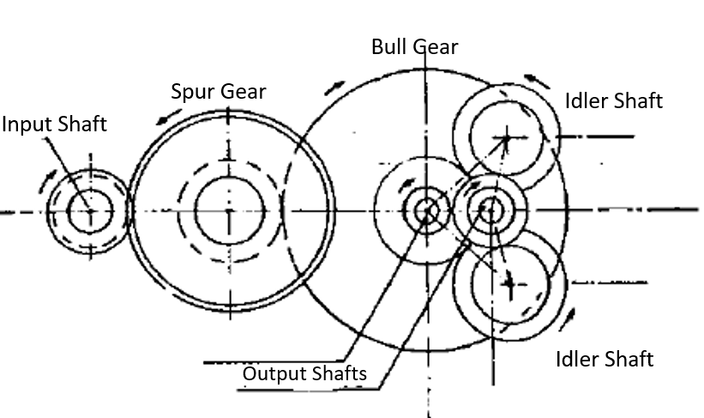

**Direction of Rotation of Shafts in Main Gear Box**

**Determining Permissible Main Dive Power & Max. Permissible Torque:**

**PVT max. (kW) = (2 x MVT x Ns)/ 9550**

Where,

PVT = Power in the processing section, in kW

2 = No. of screw shafts

MVT = Maximum permissible torque per screw shaft, in Nm

Ns = speed of the screw shaft in rpm

9550 = Conversion factor

Taking into consideration efficiency of gearbox (95%),

Maximum permissible main drive power (P mot) is calculated as:

**P Mot = PVT x 1.05**

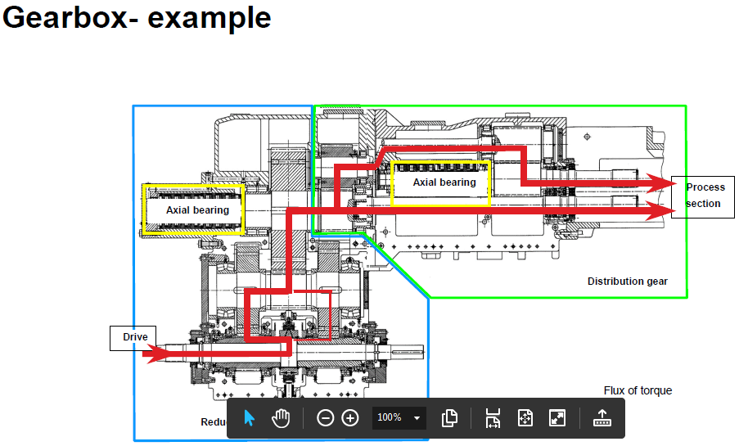**Gear Box Power Transmission**

**AUXILIARY DRIVE:**

* Extruder is having two drive mechanism.
* 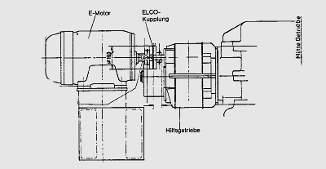Main GB & Motor and Auxiliary GB and motor.
* Auxiliary drive basically has two functions:
  1. It is used to empty the barrel from polymer after main drive stoppage to ensure low torque during next start up.
  2. Before starting the main drive, auxiliary drive is started to avoid sudden load on the clutch and main drive.
* Auxiliary drive consists of three components : Auxiliary drive motor, Auxiliary Gear box and free wheel.
* Auxiliary gearbox is three stage reduction.
* Auxilary drive motor is a 3 phase motor having capacity of 45 KW.

**AUXILIARY DRIVE-FREE WHEEL:**

* 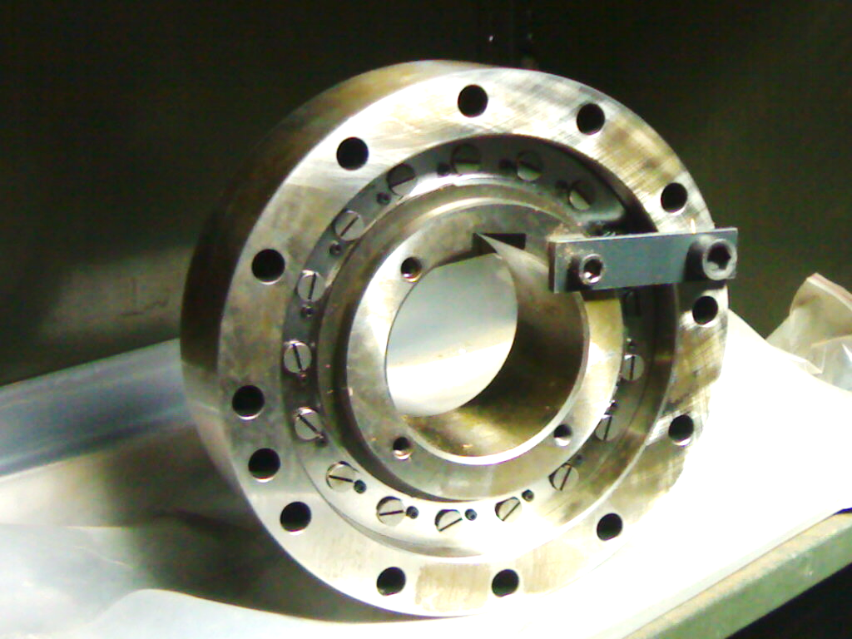Free wheels are the machine components whose input and output parts transmit torque in one direction with friction. In the other direction they run idle. Free wheels are made with individually spring loaded centrifugally disengaging sprags. Free wheels consists of cylindrical inner and outer races and individually spring loaded sprags.When the free wheels rotates ,the sprags produces frictional connection between the two races
* Freewheel mechanism allows detaching of auxiliary drive from main drive when the main drive is started.
* Function of the free wheel is to give initial motion to Extruder gear box input shaft via Auxiliary Gear box to reduce the initial torque. This Free wheel assembly acts in one direction and it gets idle in reverse direction hence direction of rotation is to be checked while mounting the free wheel assembly.
* If by any reason polymer gets solidify inside barrel, the initial torque on Auxiliary motor is heavy high and it gets tripped on overload. Repeated starting of Auxiliary drive in this condition may lead to free wheel dmage.Without this mechanism it is not possible to start the motor again and hence Free wheel required to be replaced.
* It is practiced to check the freeness of extruder screw by manually rotating the coupling of Auxiliary drive .If is hard to rotate then barrel heating temperature is raised and again freeness is checked after some time. This is done till free rotation is achieved. This practice is locally developed to protect the Free wheel brakeage.

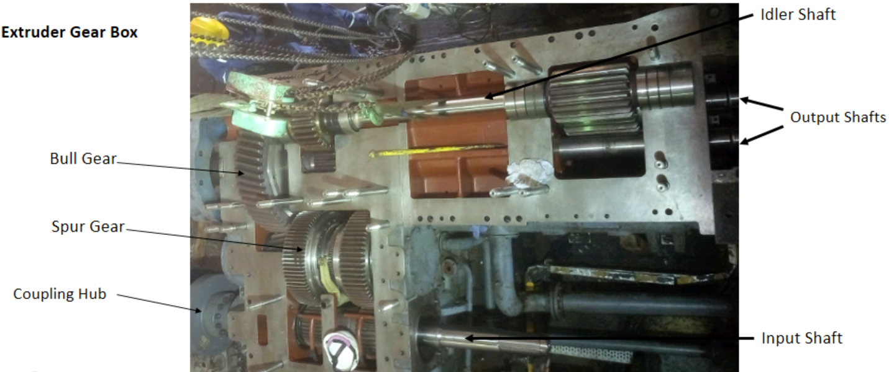**Extruder Gearbox:**

Extruder Gear Box consists of: i. Idler Shaft

ii. 2 Output Shafts

iii. Spur Gear

iv. Bull Gear

v. Input Shaft

vi. Bearing

vii. Wheel

**Prerequisites:**

* Check for any pending FAR recommendations and pending LLFS points and if so include same in job plan. Check history of work records.
* Assess the risks involved in the job,study RA and ensure that the risks are fully understood, and plan prepared to mitigate the same.
* Arrange for all spares and consumables required for job including gaskets/nuts/bolts.
* Note: Bring in advance the gear box spares and Bearing from Central store to local workshop.
* Mobilize all tools and tackles,tested lifting tools and safety appliances as per section 3.4 at the work space.Ensure that all tools are properly tested, and testing date is valid. Dented or unhealthy tools to be discarded after proper segregation.
* Make proper lightining arrangement at the work space if job is to be executed in night shift.
* Place the working Platform near PK603 foe execution of the job.
* Mobilize different trays for segregating between nuts and bolts and spares.
* The workplace should have one sack, for keeping cotton wastes.
* Make available proper supports like wooden planks for placing removed Gear Box internals.
* Obtain valid work permit (WP) along with Risk Assesment Sheet (RA) and Electrical Lock Out (MLO).
* Understand the process conditions,ensure the depressurization/Venting and isolation of the machine by checking suction,discharge Valves and Drain Valves and field Instruments. Camply with all requirements of WP/RA and sign WP for commencement of job.
* Contact the area operator, Ensure Electrical isolation of the Main ans as well as Auxiliary equipment by pressing the local push button (LPB) and display the MLO Tag on the LPB. Ensure that the MLO key is under the control of the person executing the job.
* Instruct working persons during toolbox talk about any precautions to be takes during execution of job as per annexure-II.

**Extruder Gearbox General Arrangement:**

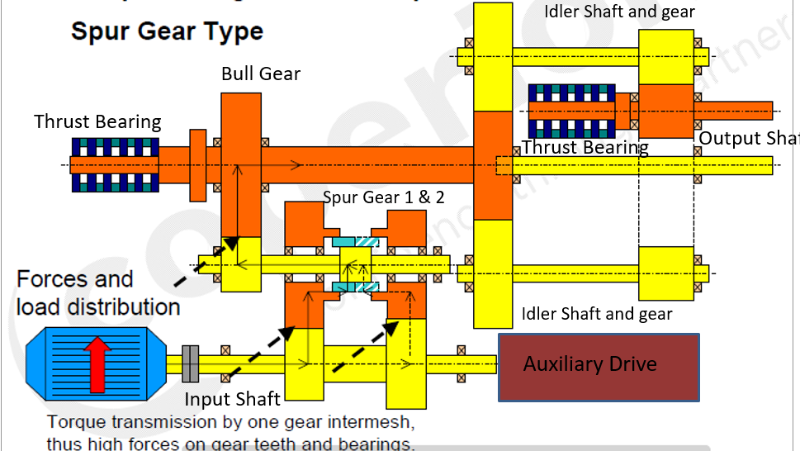

**Assembly Procedure:**

**A. Preparation**

1. Shifting of New Parts:
   * Transfer new parts from Stores to the Central Workshop.
2. Inspection of Spares:
   * Inspect all spares including Shafts, Bearings, Gear Wheels, Spacers, SUV, SPC, Oil Tempering Unit, and other miscellaneous spares.
3. Assembly Matching Check:
   * Ensure the assembly matching between existing spares (Annular Gears) with new Spur Gears.
4. Pre-Assembly:
   * Pre-assemble all bearings and gear wheels on shafts along with spacers.

**B. Assembly Procedures for Each Shaft**

**Shaft No. 1: Idler Shaft**

1. Top Idler Assembly:
   * Assemble the inner side bearings (3 no, positions 20, 21 & 19).
2. Gear Wheel Assembly:
   * Assemble the gear wheel (1 no) on the shaft using a hydraulic pump after dimensional checking (interference)
3. Outer Bearing Assembly:
   * 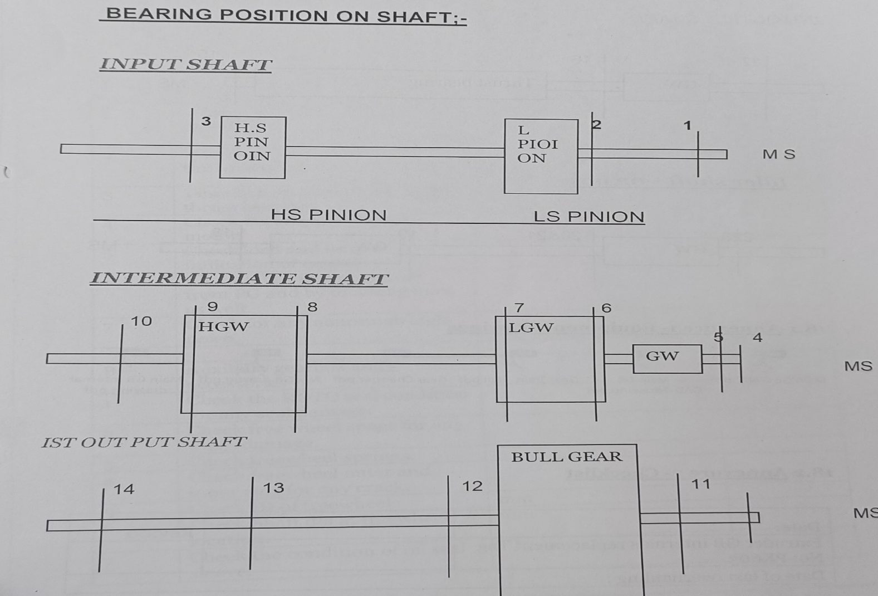Assemble the outer bearings (3 no, positions 18, 21 & 22).

**Shaft No. 2: Drive Shaft**

1. End Bearings Assembly:
   * Assemble three bearings at the end of the shaft (positions 1, 2 & 3 of Annexure-I).

**Shaft No. 3: Intermediate Shaft Assembly**

1. Ball Bearings Preloading:
   * Preload the ball bearings.
2. Space Sleeve Machining:
   * Machine the spacer sleeves of the gear wheel bearing after dimension measurement during preloading.
3. L.S Gear Wheel Assembly:
   * Assemble the L.S gear wheel with spacers and bearings on the shaft.
4. Annular Ring Dowelling and Bolting:
   * Dowel and bolt the annular ring with gear wheels.
5. Speed Changing Device Assembly:
   * Assemble the speed changing device.
6. High-Speed Gear Wheel Assembly:
   * Assemble the high-speed gear wheel with spacers and bearings.
7. Outer Bearings Assembly:
   * Assemble both shafts' end outer bearings (positions 5 & 10)

**Shaft No. 4: First Output Shaft**

1. Bull Gear Assembly:
   * Assemble the bull gear on the shaft.
2. Bearings Assembly:
   * Assemble bearings on both pieces of the shaft (5 no).
3. Shaft Assembly:
   * Assemble both shafts.
4. Thrust Bearing Assembly:
   * Assemble the thrust bearing in position.

**Shaft No. 5: Second Output Shaft**

1. Bearings Assembly:
   * Assemble bearings (4 no).
2. Thrust Bearing Assembly:
   * 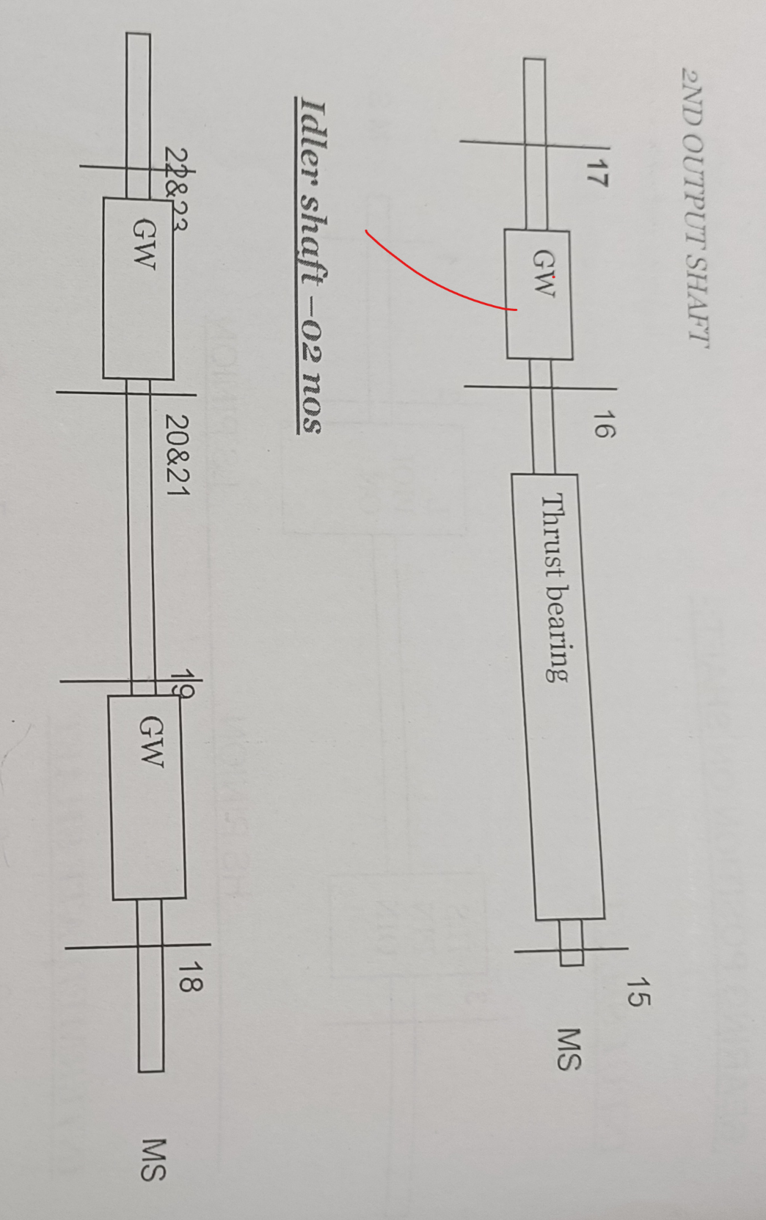Assemble thrust bearings.

**Shaft No. 6: Bottom Idler**

1. Inner Side Bearings Assembly:
   * Assemble inner side bearings (3 no).
2. Gears Assembly:
   * Assemble the gears (1 no) using a hydraulic pump after dimensional measurement (interference).
3. Outer Side Bearings Assembly:
   * Assemble outer side bearings (3 no).
4. Shifting Pre-assembled Shaft:
   * Shift the pre-assembled shaft from CESG to the plant.

**Note:** Ensure the removal of all instruments related to the job.

**C. Main Motor Coupling Removal**

1. Coupling Guard Removal:
   * Remove the coupling guard.
2. Coupling Holding Clamp Installation:
   * Mount coupling holding clamp at two locations 180 degrees apart.
3. Eyebolt Fitting:
   * Fit an eyebolt on the flexible member (part no. 32) of dwg. WB 50970-882-78 and fix a 2-ton sling with the eyebolt.
4. Coupling Bolt Loosening:
   * Loosen the coupling bolts (part no. 36 & 39) of dwg. WB 50970-882-78.
5. Push Bolt Member:
   * After loosening the bolts (pa t no. 36), push the bolt member (part no. 35) towards the motor shaft with the help of jacking bolts.
6. Coupling Lifting and Placement:
   * Lift the coupling using a chain pulley block and place it on a wooden slipper, keeping the clamp on the topside.
7. Coupling Reinstallation:
   * Reinstall the coupling after completing activity 3.2.4.14 and perform the motor alignment.

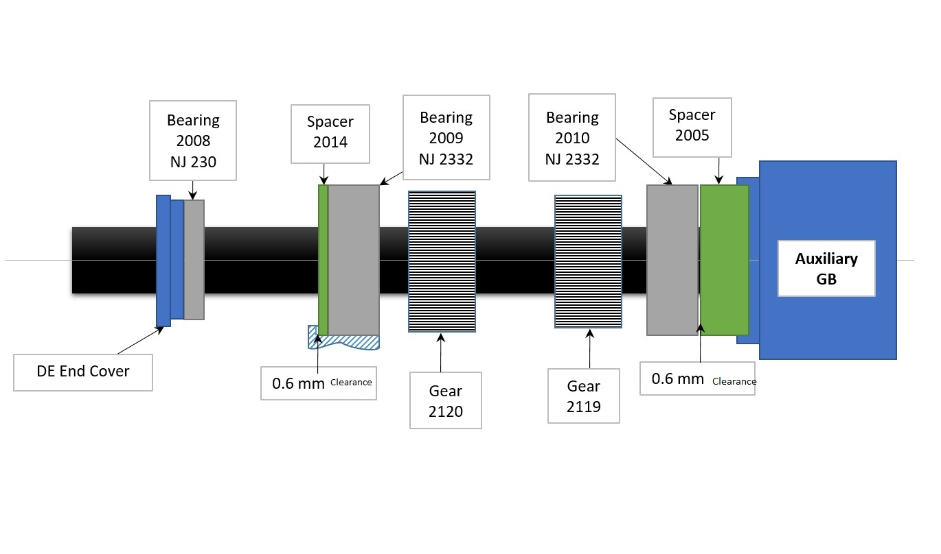**Assembly procedure for Input Shaft Assembly:**

Assembly of Input shaft of Extruder PK603 Gear Box was verified by M/S RENK, Germany as per following steps and it was verified during Clearance checking and shaft assembly.

1. Set the outer ring of bearing (2009) against spacer 2014.
2. Set clearance of 0.6mm between shoulder & roller on bearing (2009).
3. Set zero clearance between shoulder and roller on bearing (2010).
4. Install the sleeve (2005) of suitable length & uniform tightening from auxiliary gearbox bolts  
   Tightening of bolt from auxiliary drive after clearance at point 5 was checked.   
   Please also consider the depth of the centering on the auxiliary gear.
5. Set 0.6mm (tolerance + 0.2 mm) clearance between outer race and sleeve on bearing (2010).
6. Do not move the shaft after the above steps & ensure the same using dial gauge on shaft end.
7. Set 2mm clearance between shoulder and roller on bearing (2008).

**Note** : Clearance between bearing outer diameter and housing should be almost zero for all bearings. Renk confirm.

As per the given procedure Following clearances were set by M/S RENK India Representative. These clearances are required to take thermal expansion and for arresting rotor movement during operation.

**Assembly (In workshop):**

1. **Input shaft:** 
   1. 03 Nos. of bearings (02 Cylindrical roller brg in place of 02 Spherical roller brg.) were fitted on input shaft by heating the bearings in oven up to 1100C.
   2. Short length of shaft compensated by extension piece manufactured at Central workshop (as explained above).

1. **Gear Wheels of Intermediate Shaft:** 
   1. Newly supplied gear wheels were not having drilled holes for fitting of annular rings while annular rings were supplied with 06 no. of drilled holes of 18 mm ø size. The pins supplied were having 20 mm ø.

Accordingly, holes were drilled in gear wheels & after enlarging the holes of annular rings, both gear wheels & annular rings were fitted together with pins (refer photograph below).

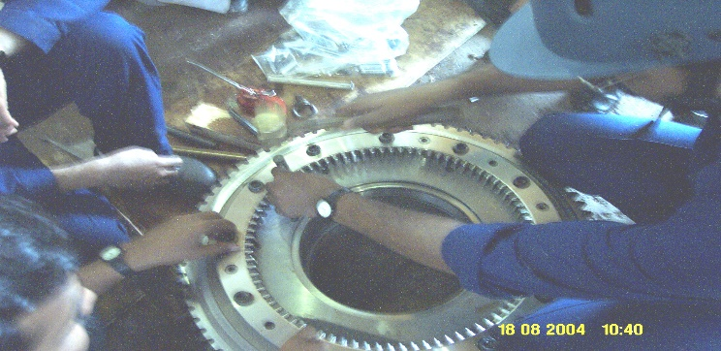

* 1. As per new design, gear wheels of intermediate shaft are fitted with ball bearings in place of cylindrical roller bearings (old design). These ball bearings are required to be preloaded in order to eliminate the axial play of bearing. This preloading was determined by applying a load of 450 kg on inner race of top brg. while bottom bearing was supported on inner race & top bearings outer race resting on bottom bearings outer race with the help of 03 nos. of cylindrical pins between them (refer photographs below).

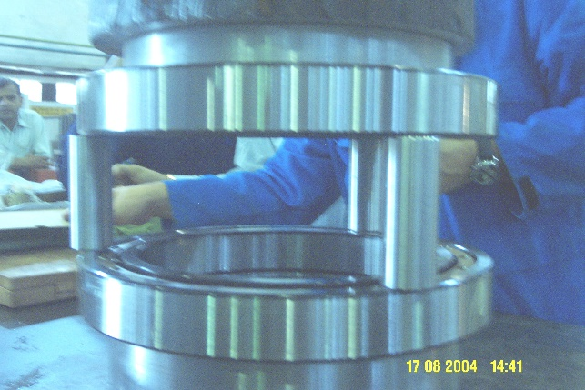

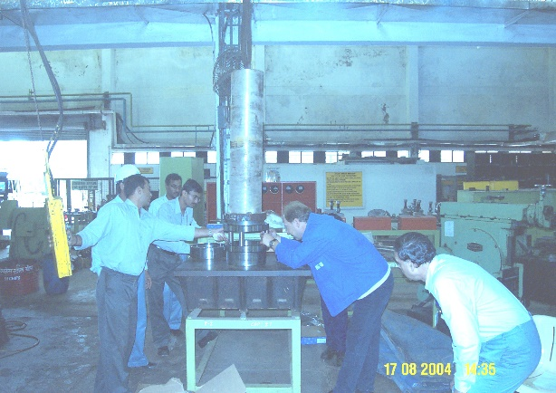

Distance between inner races of both the bearings were measured before & after applying the load. Change in distance recorded and spacer (between 02 bearings) of the gear wheels were machined and its length was kept in such a way that after assembly of bearings in gear wheel, there is no axial play in the bearings.

* 1. Two no. of ball bearings (61956) installed in L.S. gear wheel by hand push along with spacer between them. Similarly 02 nos. of 61952 bearings fitted in H.S. gear wheel.
  2. Since new gear wheel internals (portions seating on shaft) had lesser width than old gear wheels therefore additional spacers were fabricated after required measurement for proper meshing with input shaft pinions.

New spacers location: One spacer ring fitted between shrunk fit ring & L. S. gear wheel, another spacer ring fitted between shaft splines & H. S. gear wheel to locate the gear wheels at correct position.

* 1. L.S. gear wheel (along with bearings) heated in oven for about 2 hrs. up to 1400C and then installed on intermediate shaft in vertical position. After installing sliding sleeve (changing gear), H.S. gear wheel assembly also installed in similar fashion. The last component – cylindrical roller bearing installed on shaft after heating it up to 1200C.

**Site Assembly:** While installing the intermediate shaft in position, L.S. gear wheel touched a portion of casing (due to straight design of gear teeth). The fouling portions of casing were ground approx. 4 mm in depth. After completion of assembly, motor was aligned with gear box and trial taken at 5 a.m. on 20/08/2004.

**Overall changes in new assembly compared to old assembly:**

1. Input shaft: 02 no. of Spherical roller brgs were replaced by cylindrical roller bearings.
2. Input shaft length was maintained as per old shaft by attaching an extension piece.
3. Gear wheels (II shaft) were fitted with Ball bearings in place of Cylindrical roller bearings.

**Trial run observations:**

1. High speed operation restored and extruder was able to run at approx. 14T/hr. load with 80 % torque.

2. Overall noise level in gear box surrounding increased from 95 DB (before overhaul) to 105 dB.

3. Over all vibration level almost doubles (from 3 mm/s to 6 ~ 7 mm/sec.) after overhaul.

**Note:** M/s. Coperian’s Services personnel indicated that the observations (pt. no.2 & 3 above) are combined effect of spur gear design and damaged teeth / ground during overhaul of out put shaft & idler shaft. However he recommended to send vib. data to W&P Germany for further analysis & suggestions.

**Achievements of Overhaul:** Extruder load could increase from 12 T / Hrs. to 14 T / Hrs. due to increase in output speed from 181 rpm to 223 rpm, with reduced torque (from 85% to 80%).

**Recommendations of M/s Coperian’s Service Personnel:**

1. Lube oil filters to be inspected & cleaned once in a month.
2. At available opportunity, damaged gear teeth should be inspected from Inspection window.
3. Replacement of gear change lever along with other parts during next overhauling.

In view of damaged teeth at low speed side, torque should not be exceeded beyond 80 %.

**Significant Observations & Actions During and After Dismantling**

* On January 12, 2009, before the arrival of the Coperion expert, the nuts of 26 studs (of the gearbox) were opened using a hydraulic tensioner by applying 800 bar of hydraulic pressure. During this activity, three more studs broke, as shown in the figure below. Later, NDTs were carried out on the remaining studs and they were found to be in good condition. On a sample basis, two studs were checked by applying 900 bar of hydraulic pressure through the hydraulic tensioner and were found to be in good condition. Subsequently, with due consultation with the Coperion expert and GMS, it was decided to replace all 26 studs manufactured indigenously, as M/s Coperion expressed their inability to supply the complete lot within 10 weeks. The 26 studs were manufactured by a local party, M/s Dabeer Industries, Thane, based on the dimensional drawings provided by Coperion. The thread rolling was done at M/s Mega Engineering, Rabale. The quality of the studs was ensured as per the QAP drawn by the C&I wing.

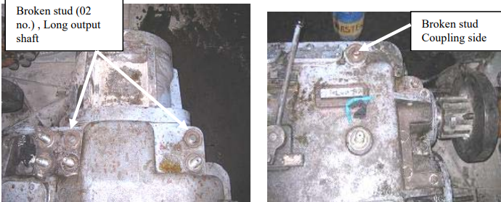Gear box casing lifting activity started on 13th Jan 09 under the supervision of coperion expert. All 06 shafts , middle & lower casing cover shifted to CWS for further inspection & dismantling of spacers for reuse if required during new assembly.

* **Bearing No. 3 (NJ2332)** of the input shaft, located near the auxiliary unit, was observed to be damaged. A lot of metallic dust was found on the inside surface of the bearing housing and spacer sleeve.

**Bearing No. 2 (NJ2332),** the middle bearing of the input shaft, was observed to have rubbing marks on the outer race, indicating its rotation in the bearing housing. Oil and heat marks were also observed on the shaft near Bearings No. 2 and 3, as shown in the picture below.

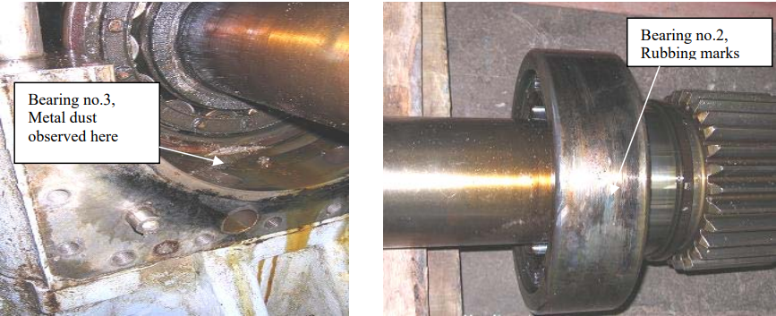

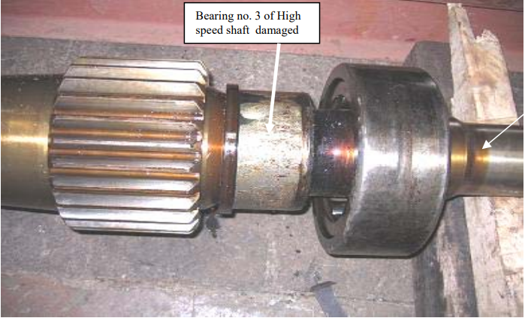One (top) fork of the gear-changing lever was observed to be broken. The broken piece (arm) was found trapped between the changing lever shaft housing and the changing gear, which was later removed after dismantling the input and intermediate shafts. During the partial overhaul (August 2004) of this gearbox, the changing lever fork arm was observed to be bent and was later straightened through heating and reused. There is a possibility that a crack developed during the heating/straightening process, which in turn caused one fork arm to break, as shown in the figure.

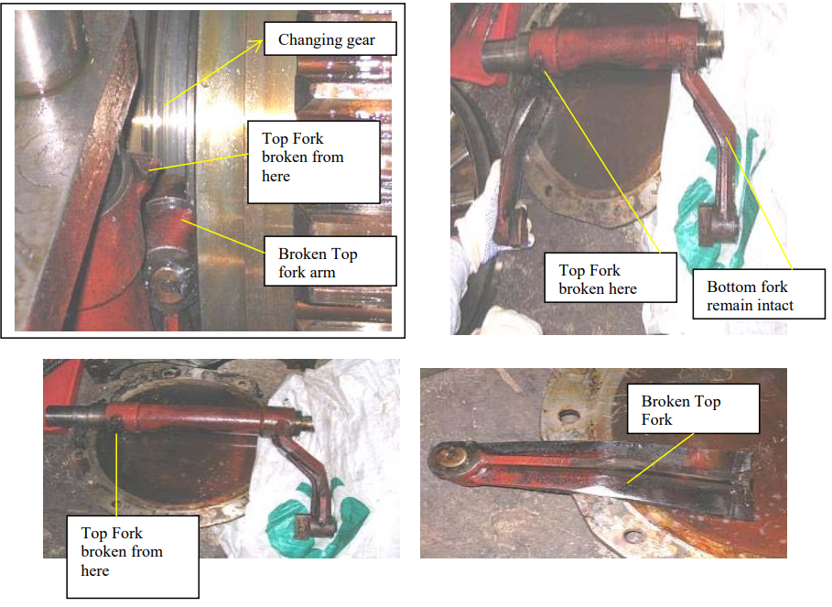

* Some of the gear teeth on the high-speed input shaft, on the auxiliary unit side, were observed to have dents, scoring, and metal flow marks. This indicates that some objects or metal pieces, possibly from the broken changing lever fork, had become trapped between the teeth and caused the damage

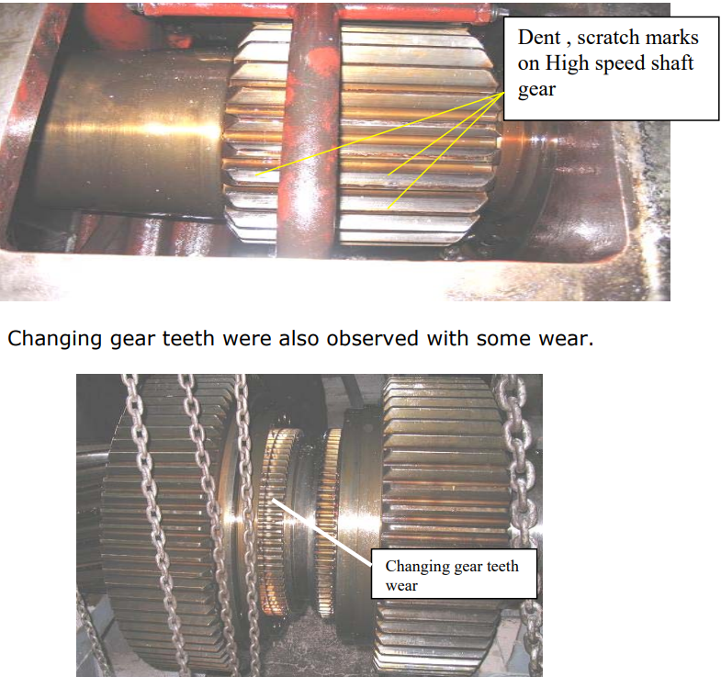

* 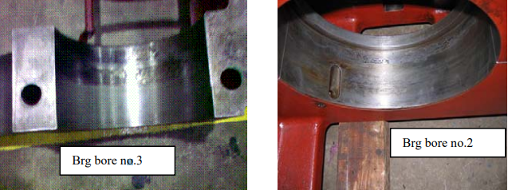Bearing housings of High speed shaft bearings(bore no.2 & 3) , NJ 2332 observed pitted &

The inside diameter measurements of both bearing housings were taken, with readings observed in the range of 340.00 to 340.03 mm, which is within the allowable tolerance H7 (0.00-0.057 mm). However, due to fretting and pitting marks covering almost 50% of the contact area, the matter was discussed with the Coperion expert and GMS. It was decided to rectify the bearing housing through machining and sleeving for the long-term reliability of the gearbox. Since the in-house boring machine facility was not sufficient to accommodate the 2.1 x 1.4 m and more than 5-ton gear casing, it was decided to outsource the rectification job. M/s Amrit Industries, Kalamboli, an RIL-approved vendor, was awarded the job after their boring machine capability was evaluated by the Coperion expert and RIL engineer. The facility was found to be excellent. The job was performed within the required tolerance limits for the bearing bores, as shown in the table below.

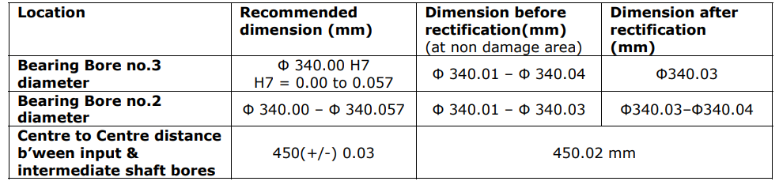

Refer following sketch of middle & bottom gear housing for required machining Dimensions:

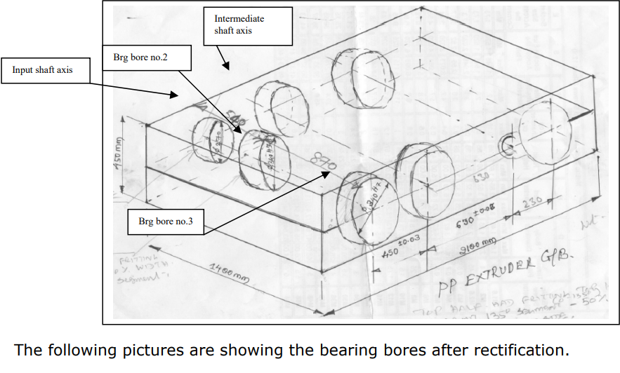

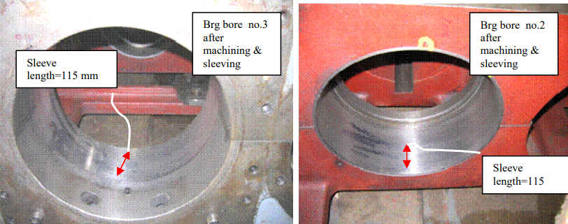

* In the meantime, the auxiliary drive gearbox (refer to the picture below) was opened and inspected. The housing of bearing 32213 (Pinion shaft 3) was observed to be badly worn out at the ID. It was later rebuilt using Stanvac–Steelweld (#Z730) cold compound and then machined to the required dimension of 310.21 mm.

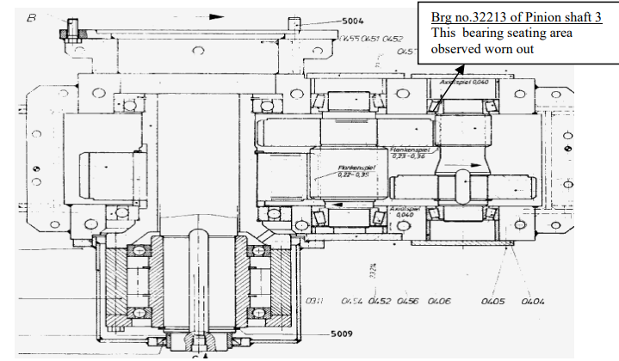

* Changing lever shaft : It was found bent up to 0.45 mm. Tried to rectify on hydraulic press but not succeeded. Finally , manufactured a new shaft in CWS.

**Assembly of Gear shafts at CES-CWS**

1. **Idler Shafts:**
   * Spacers from existing Idler shafts were removed using the arrangement as shown in picture below for use with new Idler shaft assembly. Two air operated SKF hydraulic pumps were deployed for removal of the gear wheel by expanding the bore & pulling action. Hydraulic Oil pressure vs time for bore dilation maintained as per the table below.

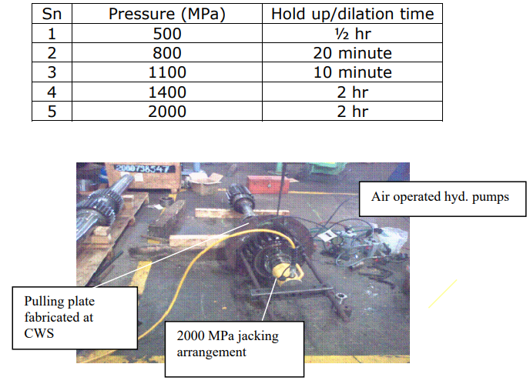

**Note : Both top & bottom Idler shafts are having 02 gear wheels One gear inbuilt & the other hydraulically mounted.**

* To achieve an interference fit of 0.26 mm, the idler shaft gear bore was heated up to 190°C in an electric furnace to expand its ID from 139.75 mm to 140.01 mm. The corresponding shaft area was cooled using dry ice. After the shaft OD was reduced to 139.75 mm (originally 140.01 mm), the gear was fitted onto the shaft. The assembly of the second idler shaft was done in the same manner. A total of 60 kg of dry ice was used for both idler shafts. The assembly of the idler shaft was completed by installing the bearings, which were a special type of coated bearing, black in color, to provide prior lubrication.

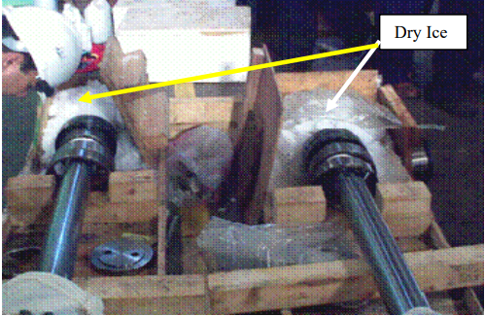

**2. Intermediate Shaft** :

* The newly supplied gear wheels came with annular rings. While the annular rings were supplied with six drilled holes of ø18 mm size, the pins provided were ø20 mm. Accordingly, holes were drilled in the gear wheels and annular rings to match the ø20 mm pins. Both gear wheels and annular rings were then fitted together with pins and bolts (refer to the photograph below).

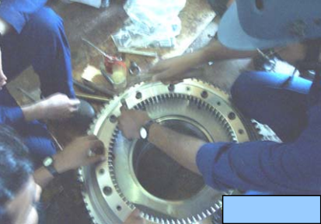

* As per the new design, the gear wheels of the intermediate shaft are fitted with ball bearings instead of cylindrical roller bearings (old design). These ball bearings need to be preloaded to eliminate axial play. This preloading was determined by applying a load of 500 kg on the inner race of the top bearing, while the bottom bearing was supported on its inner race. The outer race of the top bearing was resting on the outer race of the bottom bearing with the help of three used bearing rollers placed between them (refer to photographs below).

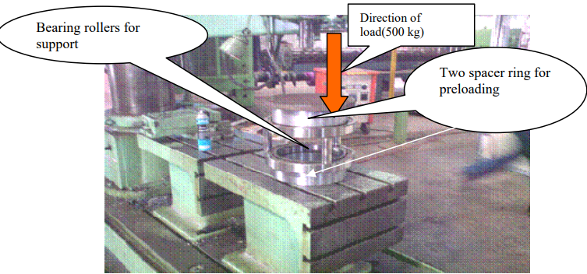

Distance measurements of the inner races of both bearings were taken before and after applying the load. These ball bearings require preloading to eliminate axial play. This preloading was achieved by applying a load of 500 kg on the inner race of the top bearing, while the bottom bearing was supported on its inner race. The outer race of the top bearing rested on the outer race of the bottom bearing with the help of three used bearing rollers placed between them (refer to photographs below).

The change in distance recorded after applying the load was 0.80 mm. Two spacer rings for preloading were machined such that their length ensured no axial play in the bearings after assembly. Therefore, the spacer sleeve length was kept 0.80 mm shorter than the distance between the steps of the gear wheel where the outer races of the two ball bearings seat.

* Two ball bearings (61956) were installed in the low-speed (L.S.) gear wheel by hand push, along with a spacer between them. Similarly, two 61952 bearings were fitted in the high-speed (H.S.) gear wheel.
* L.S. gear wheel (along with bearings) heated in oven for about 2 hrs. up to 1400 C and then installed on intermediate shaft in vertical position(refer following photograph). After installing sliding sleeve (changing gear), H.S. gear wheel assembly also installed in similar fashion. The last component ,cylindrical roller bearing installed on shaft after heating it up to 1200 C.

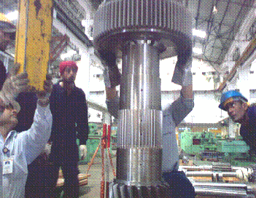

**3. Long Output Shaft & Bull Gear Assembly:**

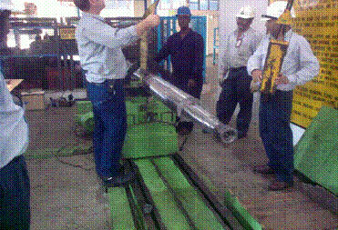The bull gear assembly involved the installation of two bearings on the thrust side after heating them in a bearing heater to 120°C. On the opposite side of the bull gear, a 24056 bearing was installed. This precise arrangement of bearings ensures the bull gear operates smoothly, accommodating the necessary thrust and radial loads.

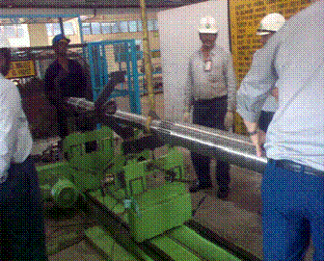The long output shaft, supplied in two parts, was assembled by tightening the threaded connection between them using a 20-pound hammer. This method ensured a secure and robust connection. The combined shaft was then carefully inserted into the bull gear sleeve. To guarantee the correct alignment of the two shaft parts, this activity was performed on a balancing machine, ensuring the assembly maintained proper balance and function.

Following the shaft assembly, bearings were mounted onto the shaft. This meticulous assembly process, from heating the bearings to ensuring the correct alignment on a balancing machine, is crucial for the efficient and reliable operation of the bull gear and output shaft in the extruder gearbox system.

1. **Short Output Shaft Assembly:**

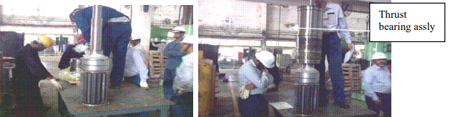Tandem thrust bearing assembly & radial bearing assembly done in the workshop on short out put shaft as shown in the pictures below.

To ensure the proper preloading of the short output shaft thrust bearing, the compression was verified using a bearing puller. According to the OEM guidelines, the Belleville washer, which is part of the thrust bearing assembly, should exhibit a compression of 0.32 mm.

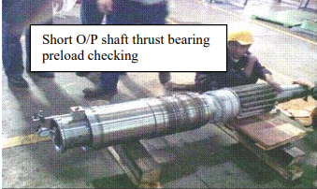

1. **Input(High Speed) Shaft Assembly:**

All three bearings—NJ 230 (bearing no.1), NJ 2332 (bearing no.2), and NJ 2332 (bearing no.3)—were assembled on the high-speed shaft after heating them to 120°C using an induction heater.

**Note:** The originally installed bearings, NJ 230 (1 no.) and 22332 (2 no.), were replaced with the aforementioned roller bearings during a partial overhaul in August 2004. The same design bearings are maintained in the current overhaul.

1. 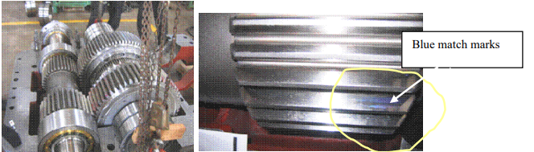**Blue matching of high speed shaft gears with Intermediate shaft gears** :

A 25% tooth contact was obtained after the blue match test. According to OEM guidelines, a 25% match corresponds to 90-95% tooth contact during actual operating conditions. This verification also confirmed the excellent quality of workmanship in the rectification of the bearing housing.

Following the blue match checking, the coupling was installed using an air-operated SKF hydraulic arrangement and a hydraulic axial pusher.

* The hydraulic pressure was set to 1300 bar to expand the coupling hub bore.
* The hydraulic pressure for the pusher was set to 50 bar.

The recommended total axial movement of 12.5 mm for the coupling, due to hydraulic push, was achieved.

**8. Checking of Newly Manufactured Studs at Site**

All studs were fitted in their respective locations before erecting the gearbox casing halves. Each stud was checked for elongation at 900 bar hydraulic pressure using a hydraulic tensioner device. All 26 studs were found ok.

**SITE ASSEMBLY WORK**

* All the gear shafts were placed in their designated locations, and the float of the long output shaft was checked according to the following picture, showing a float of 0.4 mm, which was within acceptable limits.

The sequence of erection of the gear shafts and gearbox casings was as follows:

* Lower Idler Shaft
* Lower Level Casing
* Short Output Shaft
* Long Output Shaft
* Intermediate Shaft
* Input Shaft
* Middle Level Casing
* Top Idler Shaft
* 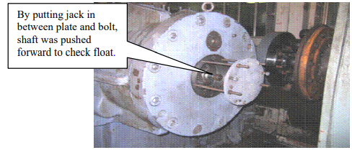Top Level Casing
* **Timing Setting of Lower & Top Idler Shaft:**

This exercise was performed after installing the lower idler shaft, lower level casing, short output shaft, long output shaft, intermediate shaft, and high-speed shaft. The hydraulic arrangement, as shown in the picture, was set up to expand the lower idler shaft's gear. The timing setting of both output shafts was achieved by expanding the hydraulically mounted gears of both idler shafts.

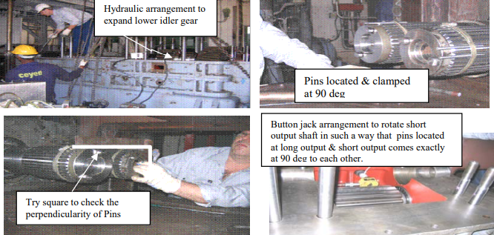The distance between the pins (as per following picture) measured & found to be same. This indicates the perfect timing of the lower idler shaft w.r.t short & long output shaft.

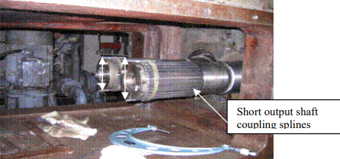

Now, the middle level casing was installed. A similar exercise, as described above, was carried out to set the timing of the upper idler shaft with respect to the short and long output shafts.

Blue matching was performed and found to be in accordance with OEM guidelines. The tooth contact details are as follows:

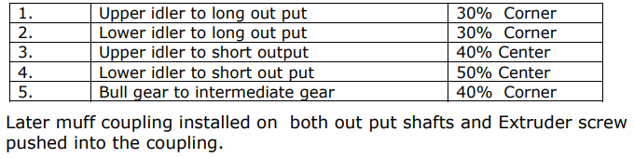

* Later top half of the casing erected and found that lubrication pipe was touching the gear wheel of the input shaft. This was due to the large size of the gear wheel of up rated input shaft. The same was adjusted by shifting the pipe upwards & relocating the pipe support.
* Finally Casing studs were tightened at 900 bar hydraulic pressure using hydraulic tensioning device.

**TRIAL RUN**

* **Motor and Gearbox Alignment Process**

Upon completing the assembly, the gearbox was cold aligned with the motor by a Coperion expert. To accommodate the thermal growth of the motor, the motor was initially positioned 0.5 mm higher and 0.2 mm offset to the north side relative to the gearbox.

After a 48-hour trial run, the extruder was stopped, and hot alignment between the motor and gearbox was checked. The alignment was found to be within a tolerance of 0.02 mm, indicating successful accommodation of thermal expansion. The trial was conducted on February 7th, 2009, at 11:23 PM.

During the trial, vibration levels, dB(A), and dB(C) sound levels were monitored and found to be within acceptable limits. The maximum baseline vibration observed was 2 mm/s, and the dB(A)/dB(C) levels were recorded at 40/32, respectively.

**Achievements of Overhaul:**

* **Timely Correction of High-Speed Shaft Bearing Housing**: The timely correction of the high-speed shaft bearing housing prevented more severe damage to the gearbox casing.
* **Long-Term Equipment Availability**: The corrective measures ensured the availability of the equipment for long-term and uninterrupted operation.
* **Operational Flexibility**: Following the adjustments, it is now possible to operate the extruder at both low (227 rpm) and high speeds (258 rpm).

**Lessons Learnt:**

* **Vendor Readiness**: A list of approved vendors capable of handling heavy and precise machining jobs should be readily available on-site. This will help avoid delays in vendor identification during critical overhauling work.
* **Impact of Bearing Housing Machining**: During the gearbox revamp, the critical activity of bearing housing machining controlled the entire overhauling schedule. Despite a delay in ordering 26 studs, it did not impact the overall planning, which could have otherwise jeopardized the job completion timeline.
* **Efficient Decision-Making for Stud Replacement**: The decision-making process regarding whether to replace only the 4 broken studs or all 26 took considerable time due to the need for detailed non-destructive testing (NDT), chemical analysis reports, and manufacturing drawings. This delay could have been minimized if all necessary drawings were available beforehand.

**Bearing Failure Analysis and Solution**

**Root Causes for the Bearing Failure:**

1. **Outer Diameter Deviation:**
   * The outer diameter of the failed bearing was measured to be 269.45mm, which is below the standard diameter of 270mm. This dimensional discrepancy likely contributed to the bearing failure.
2. **Dimensional Tolerance Errors:**
   * There were suspected errors in the dimensional tolerance between the inner race and the rollers of the bearing. These tolerance errors can cause improper load distribution and increased wear.
3. **Gearbox to Motor Alignment Issues:**
   * Misalignment between the gearbox and the motor was noted. The initial alignment check revealed a deviation of 0.40mm, which is beyond acceptable limits. Misalignment can lead to uneven loading on the bearings, causing premature failure.

**Detailed Finding and Activities:**

1. **Initial Inspection and Disassembly**:
   * Oil leakage was observed at the labyrinth seal of the input shaft drive end during the trial run.
   * Debris was found in the end cover bottom slot, and oil drain holes were clogged, indicating poor maintenance.
   * Bearing failure was partially confirmed through the removal of the end cover, leading to the decision to dismantle the top cover for a detailed inspection.
2. **Bearing Removal and Measurement**:
   * The failed bearing’s outer race and inner race were removed using the cutting method.
   * Measurements of the bearing seating diameters were taken and found to be within the design limits.
   * The outer diameter of the failed bearing was confirmed to be 269.45mm against the standard 270mm.
3. **New Bearing Installation**:
   * New bearings were installed, with the input shaft assembly being shifted to the workshop for the replacement process.
   * The gaps between the spacers and the inner race were checked and found to be within the design protocol without requiring any modifications.
   * The alignment of the gearbox to the motor was rechecked and adjusted to meet the precise alignment values (0.2mm radial and 0.2mm offset).

**Solutions and Recommendations:**

To prevent future bearing failures, the following actions are recommended:

1. **Regular Dimensional Checks**:
   * Conduct regular dimensional checks of bearings during maintenance to ensure they meet the standard specifications.
   * Implement a stringent quality control process to verify the dimensions of new bearings before installation.
2. **Improving Tolerance Management**:
   * Enhance the precision in manufacturing and assembly processes to maintain proper tolerances between bearing components.
   * Use high-quality bearings with improved tolerance grades to reduce the likelihood of dimensional errors.
3. **Ensuring Proper Alignment**:
   * Perform precise alignment checks between the gearbox and the motor during installation and routine maintenance.
   * Use advanced alignment tools and techniques to achieve and maintain the correct alignment specifications.
4. **Maintenance and Monitoring:** 
   * Implement a comprehensive maintenance schedule that includes regular inspections and cleaning of oil drain holes and filters.
   * Monitor the condition of bearings and lubrication systems continuously using condition monitoring techniques such as vibration analysis and oil analysis.
5. **Training and Awareness**:
   * Provide training for maintenance personnel on the importance of dimensional checks, proper alignment, and tolerance management.
   * Raise awareness about the potential causes and consequences of bearing failures to encourage proactive maintenance practices.

*By following these analysis and solutions, the reliability and performance of the extruder gearbox can be significantly improved, reducing the likelihood of bearing failures and enhancing overall operational efficiency.*

**Project Conclusion**

During my summer internship at Reliance Nagothane, I thoroughly studied the extruder gearbox and analyzed input shaft bearing failure. This project significantly enhanced my understanding of mechanical systems in polymer processing.

**Key Insights**

* **Overview of the Extruder**: Gained comprehensive knowledge of extruder types and functions, crucial for understanding the gearbox.
* **Gearbox Assembly**: Learned about the components and precision required in assembly.
* **Detailed Assembly Procedure**: Improved technical documentation and communication skills.
* **Bearing Assembly Sequence**: Understood the critical installation methods to ensure gearbox integrity.
* **Bearing Failure Analysis**: Identified factors such as improper lubrication, misalignment, and material fatigue, and recommended preventive measures.

**Key Learnings and Future Implications:**

Through this project, I have gained valuable hands-on experience and a deeper understanding of mechanical systems within the polymer processing industry. The knowledge acquired from this study will undoubtedly serve as a strong foundation for my future endeavors in mechanical engineering.

*In conclusion, this internship was an enriching experience that prepared me for future engineering challenges and significantly contributed to my professional growth.*